The Progress Electronic Magazine

In this issue:

Publisher’s Statement: 2
The Open Source Corner: 3
Coding Article: Webspeed and Palm Pilots (PDAs) 5
Theory of Operation 6
ListArt.html 7
DispArt.html 9
Setting up the channel on Avantgo’s web site: 11
Other interesting pages: 15
Management Article: Pricing Proposal 16
Type of contract 16
Development cost by component completion 16
Subcontractor costs 16
Procurement costs 17
Overhead costs 17
Warranty 17
Profit 17
Total Project Cost 17
Payment Schedule 17
Billing and Administration 17
Community Announcements: 18
Product Announcements: 18
Survey Software 18
Publishing Information: 19
Article Submission Information: 19

Did you sign up to receive this E-Zine? Send email to sauge@amduus.com to subscribe or fill out the forms at http://www.amduus.com/online/dev/ezine/EZineHome.html ! It’s free! (Though donations are certainly welcome – whatever you feel is fair!)

Though intended for users of the software tools provided by Progress Software Corporation, this document is NOT a product of Progress Software Corporation.

Publisher’s Statement:

This month I explore the use of Webspeed in conjunction with the Avantgo HTTP client available on the Palm OS and Windows CE compatible PDAs. A simple partner information system is written to explore the use of this technology. This is a simple content management system allowing users to access news and updates from the company.

Included also is the continuation of the series for proposals.

Also would like to say – still looking for work in the Progress space! Would appreciate some emails or phone calls from people who have something.

I am also looking for resellers for the Service Express product. Need something to work on? Here is your opportunity to make work for yourself!

Also, if you are a consultant, and know of any small or medium business that could benefit from a web based help desk like Service Express – please contact me. I would like to set up a network of people who would bring in and aid customers with ASP Service Express. Sell the idea, configure the app (via the web), support questions, and provide training. We take care of the rest on our website and servers.

If you have an idea, and a marketing plan as well people who can perform the sales actions, let me know – we might be able to write some code to make your product come alive!

I have also started a new section called The Open Source Corner. This is best for programmers because with Open Source, it is not only the corporation that benefits, but the programmer also. Source code means jobs. Source code means needing someone around to make sense of it. Source code is good.

To your success,

Scott Auge
Founder, Amduus Information Works, Inc.
sauge@amduus.com

The Open Source Corner:

I have released a couple of new open source products. One is DBEmail – available at freeframework.org and amduus.com. This will suck in emails from a pop3 mail box and use a searchable web site to search them. Makes the knowledge a little more available to people within an organization. (Be forewarned, it is pretty rough around the edges, but is functional.)

The other is CMS – a content management system for web sites. Eases the ability of people to post new articles on the web site, as well keep the web site updated automatically. I will be converting Amduus to this shortly, so there will be a production use of the code base. An unnamed company will also be using this system.

Rares STANCIULESCU has released an open source product similar to CMS at https://sourceforge.net/projects/wsnewskit and one can see it at work at http://80.65.226.179/news.html.

This site is an interesting find – it helps develop business cases for the use of Linux in the enterprise.

http://www.aaxnet.com/design/linux0.html

If you have open source apps/tools for the Progress environment – and even update messages, please send them along and I will post that information in the next E-Zine.

Coding Article: Webspeed and Palm Pilots (PDAs)

Written by Scott Auge

Wireless and remote devices are becoming far more common in both the consumer and enterprise marketplace. This article explores the use of Webspeed/Blue Diamond to construct a simple content management program to send and display articles to a Palm Handheld using the Avantgo Web browser.

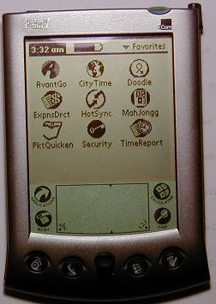
Avantgo Browser
Applications Screen of Palm
with Avantgo Browser

The Avantgo web browser client is available from Avantgo.com for free. One can also set up personal “channels” which really are web sites using the special HTML the Avantgo client can render.

Theory of Operation

Only the source code relevant to getting information to the Palm Device will be detailed here. The source code as well the database definition file can be obtained from the Open Source area of www.amduus.com.

The content display portion consists of two simple web pages as diagramed:

Two web pages making up content system
relevant to the Palm device

The ListArt.html page will contain links with named value pairs to DispArt.html. These named value pairs will be used to identify which record in the database should be brought up and rendered by the Webspeed Transaction Server or Blue Diamond Transaction Server.

This program was tested with a Palm V handheld. It does not have a continuous connection to the internet, so during Hot Syncs, it downloads the web sites into memory for display on the screen. Some setting up is needed to do this, and that is presented later in the article. The server is Red Hat Linux for VA Linux version 6.2. The Progress version is 9.1A with Blue Diamond 1.6.6 or Webspeed 3.1.

The element of code that the Avantgo WWW browser needs is a meta setting highlighted in RED in the code below. The E4GL mark-ups are done in BLUE. The web browser can handle most HTML tags – one mostly only has to consider for screen size.

ListArt.html
The purpose of this page is to create a list of titles to the articles within the content management system. It is the opening page of the site that conveniently lists the articles available within the system.

It is a simple HTML page that matches the needs as specified in the Avantgo client manual for developing web pages. In general, it is developing HTML that can be viewed on a small screen, as well understanding the use of the client in a disconnected mode.

<!--WSS
/*
* Written by Scott Auge scott_auge@yahoo.com sauge@amduus.com
* Copyright (c) 2001 Amduus Information Works, Inc. www.amduus.com
*
* Redistribution and use in source and binary forms, with or without
* modification, are permitted provided that the following conditions
* are met:
* 1. Redistributions of source code must retain the above copyright
* notice, this list of conditions and the following disclaimer.
* 2. Redistributions in binary form must reproduce the above copyright
* notice, this list of conditions and the following disclaimer in the
* documentation and/or other materials provided with the distribution.
* 3. All advertising materials mentioning features or use of this software
* must display the following acknowledgement:
* This product includes software developed by Amduus Information Works
* Inc. and its contributors.
* 4. Neither the name of Amduus Information Works, Inc. nor the names of
* its contributors may be used to endorse or promote products derived
* from this software without specific prior written permission.
*
* THIS SOFTWARE IS PROVIDED BY AMDUUS AND CONTRIBUTORS ``AS IS'' AND
* ANY EXPRESS OR IMPLIED WARRANTIES, INCLUDING, BUT NOT LIMITED TO, THE
* IMPLIED WARRANTIES OF MERCHANTABILITY AND FITNESS FOR A PARTICULAR PURPOSE
* ARE DISCLAIMED. IN NO EVENT SHALL THE AMDUUS OR CONTRIBUTORS BE LIABLE
* FOR ANY DIRECT, INDIRECT, INCIDENTAL, SPECIAL, EXEMPLARY, OR CONSEQUENTIAL
* DAMAGES (INCLUDING, BUT NOT LIMITED TO, PROCUREMENT OF SUBSTITUTE GOODS
* OR SERVICES; LOSS OF USE, DATA, OR PROFITS; OR BUSINESS INTERRUPTION)
* HOWEVER CAUSED AND ON ANY THEORY OF LIABILITY, WHETHER IN CONTRACT, STRICT
* LIABILITY, OR TORT (INCLUDING NEGLIGENCE OR OTHERWISE) ARISING IN ANY WAY
* OUT OF THE USE OF THIS SOFTWARE, EVEN IF ADVISED OF THE POSSIBILITY OF
* SUCH DAMAGE.
*
*/

DEF VAR RCSVersion AS CHARACTER INIT "$Header$" NO-UNDO.

-->

<html>
<head>
<title>List Articles</title>
<meta http-equiv="Content-Type" content="text/html; charset=iso-8859-1">
<meta name="HandheldFriendly" content="True">
</head>

<body bgcolor="#FFFFFF">
<p><b>Updates from Amduus</b></p>
<!--WSS

/* Display 10 days of articles */

FOR EACH Article NO-LOCK
WHERE Article.StartDate > TODAY - 10:
-->
<p><a href="DispArt.html?ArticleID=`Article.ArticleID`">`Article.ArticleTitle` </a><br>
<!--WSS
END. /* FOR EACH Article */
-->
</p>
</body>
</html>

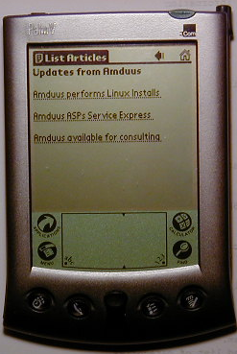

The ListArt.html page on the Palm V

DispArt.html
This program will display an individual article within the content management system. It uses a NVP (Name-Value Pair) to identify the record associated with the article. The entire text of the record is rendered via the Article.ArticleText field reference.

<!--WSS
/*
* Written by Scott Auge scott_auge@yahoo.com sauge@amduus.com
* Copyright (c) 2001 Amduus Information Works, Inc. www.amduus.com
*
* Redistribution and use in source and binary forms, with or without
* modification, are permitted provided that the following conditions
* are met:
* 1. Redistributions of source code must retain the above copyright
* notice, this list of conditions and the following disclaimer.
* 2. Redistributions in binary form must reproduce the above copyright
* notice, this list of conditions and the following disclaimer in the
* documentation and/or other materials provided with the distribution.
* 3. All advertising materials mentioning features or use of this software
* must display the following acknowledgement:
* This product includes software developed by Amduus Information Works
* Inc. and its contributors.
* 4. Neither the name of Amduus Information Works, Inc. nor the names of
* its contributors may be used to endorse or promote products derived
* from this software without specific prior written permission.
*
* THIS SOFTWARE IS PROVIDED BY AMDUUS AND CONTRIBUTORS ``AS IS'' AND
* ANY EXPRESS OR IMPLIED WARRANTIES, INCLUDING, BUT NOT LIMITED TO, THE
* IMPLIED WARRANTIES OF MERCHANTABILITY AND FITNESS FOR A PARTICULAR PURPOSE
* ARE DISCLAIMED. IN NO EVENT SHALL THE AMDUUS OR CONTRIBUTORS BE LIABLE
* FOR ANY DIRECT, INDIRECT, INCIDENTAL, SPECIAL, EXEMPLARY, OR CONSEQUENTIAL
* DAMAGES (INCLUDING, BUT NOT LIMITED TO, PROCUREMENT OF SUBSTITUTE GOODS
* OR SERVICES; LOSS OF USE, DATA, OR PROFITS; OR BUSINESS INTERRUPTION)
* HOWEVER CAUSED AND ON ANY THEORY OF LIABILITY, WHETHER IN CONTRACT, STRICT
* LIABILITY, OR TORT (INCLUDING NEGLIGENCE OR OTHERWISE) ARISING IN ANY WAY
* OUT OF THE USE OF THIS SOFTWARE, EVEN IF ADVISED OF THE POSSIBILITY OF
* SUCH DAMAGE.
*
*/

DEF VAR RCSVersion AS CHARACTER INIT "$Header$" NO-UNDO.

DEF VAR cArticleID AS CHARACTER NO-UNDO.

ASSIGN cArticleID = GET-VALUE("ArticleID").

/* Note that this assumes that the article is available. There should be a */
/* response for articles that are not available. This code does not ac- */
/* complish this for sake of clarity of getting a page out to the Palm */
/* device. */

FIND Article NO-LOCK
WHERE Article.ArticleID = cArticleID
NO-ERROR.

-->

<html>
<head>
<title>Display Article</title>
<meta http-equiv="Content-Type" content="text/html; charset=iso-8859-1">
<meta name="HandheldFriendly" content="True">
</head>

<body bgcolor="#FFFFFF">
<p><b>`Article.ArticleTitle`</b></p>
<p> `Article.ArticleText` </p>
</body>
</html>

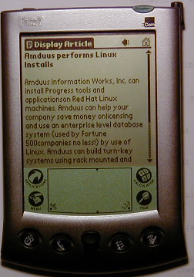

Viewing an article on the Palm V via Blue Diamond

Setting up the channel on Avantgo’s web site:

Setting up a channel on the Avantgo web site is easy. This way simple development or even becoming an Avantgo content provider can be done. Note that this would be a public site available if done this way – and one may want to buy the Avante Go software package to run on one’s own servers if it is to be used within a company.

In short, create an account ID on www.avantgo.com and create a channel by pointing a URL and naming it. One will want to set the depth of the web site to match the deepest link you may have on your site. In other words, if it takes five clicks to reach into the web site, you would want the depth to be five.
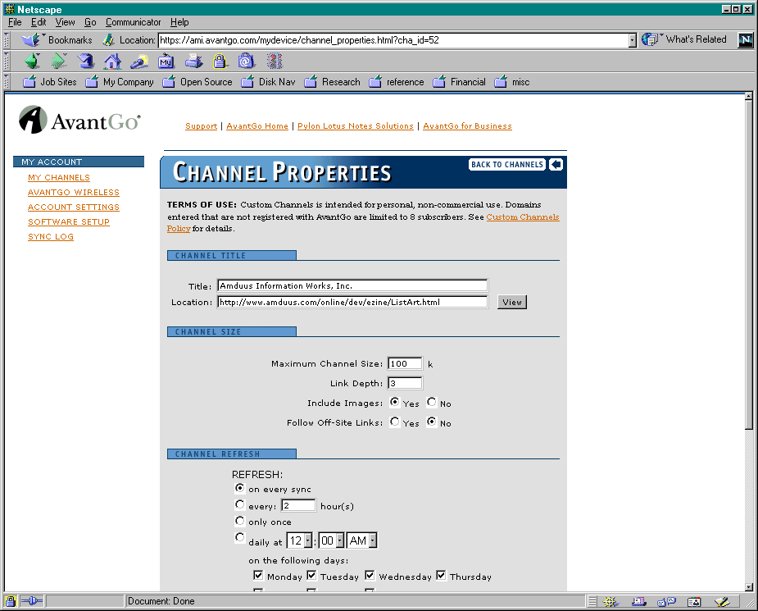
Creating a channel on the Avantgo Web Site

After performing a Hot Sync, the channel appears on the Client:

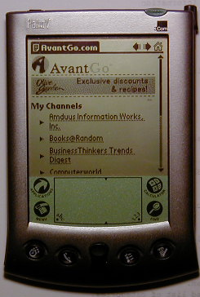
Amduus Information Works, Inc. Channel

The Amduus Information Works, Inc. Channel on the WWW Client

The web browser can support forms, cookies, SSL, as well as limited JavaScript and Apache password authentication. Of course, by use of cookies or NVPs, one can authenticate a user within the E4GL application.

Database Table:

12/31/01 15:37:33 PROGRESS Report
Database: amduus (PROGRESS)

=========================================================================
============================= Table: Article ============================

Table Flags: "f" = frozen, "s" = a SQL table

Table Dump Table Field Index Table
Name Name Flags Count Count Label
----------------------------- -------- ----- ----- ----- -------------------
Article article 6 3 Article

Description: Articles within a content management system
Storage Area: Schema Area

============================= FIELD SUMMARY =============================
============================= Table: Article ============================

Flags: <c>ase sensitive, <i>ndex component, <m>andatory, <v>iew component

Order Field Name Data Type Flags Format Initial
----- ------------------------- ----------- ----- --------------- ----------
10 ArticleID char i x(8)
20 ArticleTitle char x(8)
30 ArticleText char x(8)
40 StartDate date i 99/99/99 ?
50 EndDate date 99/99/99 ?
60 CategoryID char i x(8)

Field Name Label Column Label
------------------------------ ---------------------- ----------------------
ArticleID ArticleID ArticleID
ArticleTitle ArticleTitle ArticleTitle
ArticleText ArticleText ArticleText
StartDate StartDate StartDate
EndDate EndDate EndDate
CategoryID CategoryID CategoryID

============================= INDEX SUMMARY =============================
============================= Table: Article ============================

Flags: <p>rimary, <u>nique, <w>ord, <a>bbreviated, <i>nactive, + asc, - desc

Flags Index Name Cnt Field Name
----- -------------------------------- --- ---------------------------------
key1 1 + StartDate

key2 1 + CategoryID

pu pukey 1 + ArticleID

** Index Name: key1
Storage Area: Schema Area
** Index Name: key2
Storage Area: Schema Area
** Index Name: pukey
Storage Area: Schema Area

============================= FIELD DETAILS =============================
============================= Table: Article ============================

Other interesting pages:

Creating a Avantgo channel:

http://ami.avantgo.com/support/developer/channels/

Supported HTML tags:

http://ami.avantgo.com/support/developer/supported_tags/bigmatrix.html

Application Developer page:

http://ami.avantgo.com/support/developer/apps/

About the author: Scott Auge is the founder of Amduus Information Works, Inc. He has been programming in the Progress environment since 1994. His works have included E-Business initiatives and focuses on web applications on UNIX platforms. sauge@amduus.com

Management Article: Pricing Proposal

Written by Scott Auge sauge@amduus.com

Type of contract
Under this heading one would state whether the contract was fixed price or time and materials.

Fixed cost means that no matter what, the company will provide the customer a service for a given amount of work. Fixed cost contracts are good for well established processes and available applications. Examples are installing Progress and or installing a Progress application. One understands the steps involved intimately and can perform them in a measured way.

Time and materials is for that work which has not been explored already. Time and materials is good for application development or customization. This is because developing an application can have hidden gotcha’s and a lot of politics involved. The customer may change their minds, algorithms may take longer to sort out than expected, etc.

Development cost by component completion
Identify the components associated with the project and the costs associated with it. This can help identify large capital outlays in the beginning or the end.

Subcontractor costs
If there are sub-contractors, and you are inclined to note that you are using sub-contractors (perhaps because of their previous work or reputation) – you can note them in this section. This section can be optional. Government contracting normally requires sub-contractor information.

Procurement costs
If one is making a turn key system for the customer, or taking on expenses to provide them a system., you may want to list these out. Such things as hardware, or software, or printing expenses can be listed here. Government contracting normally requires this information.

Overhead costs
Identification of the overhead costs may be required for some government contracts. Examples are temporary office space, staff, etc. One may especially include ownership costs such as positions that need to be hired (DB Admins, programmers, etc.), software costs (licensing, maintenance costs), and training costs.

Warranty
If there is a warranty, it should be noted here.

Profit
Government contracts usually require a profit clause. Private company contracts generally do not need this information.

Total Project Cost
A summary of cost items for the company to consider.

Payment Schedule
The payment schedule is outlined in this section. If payments are associated to milestones, then it should be noted, otherwise the exact dates and the amounts. The number of days a payment can be in arrears can be noted here also.

Billing and Administration
This section identifys where payments should be sent, and in what form (check, electronic commerce, etc.) Any additional information such as is an invoice is required to sent also, etc.
Portions of this article based on:

E.M. Bennatan, “On Time, Within Budget – Software Project Management Practices and Techniques” ISBN 0-89435-408-6

About the author: Scott Auge is the founder of Amduus Information Works, Inc. He has been programming in the Progress environment since 1994. His works have included E-Business initiatives and focuses on web applications on UNIX platforms. sauge@amduus.com

Community Announcements:

A place to announce Progress User Groups, Open Source Exchanges, etc. No charge!

Wonder where to find those Progress marketing articles?

http://www.progress.com/analyst/
http://www.progress.com/profiles/index.htm
http://www.progress.com/success/index.htm

Progress in the news sighting!

A major international car-rental company has switched from Oracle Corp. to
Progress Software Corp. for its centralized reservation and back-office systems,
saying Progress is handling the project more quickly and at lower cost than a
contractor working with Oracle architecture.

http://computerworld.com/nlt/0%2C3590%2CNAV47_STO65971_NLTAM%2C00.html

Product Announcements:

Survey Software
Amduus Information Works, Inc. is creating survey software. This software can be used on a web site to query a population of people about their views and needs. The population could be internal to a company or external to yield a better understanding of the marketplace. Documentation for the application will be available at http://www.amduus.com for free download.

The software ships with source code for better adaptability to your company’s application landscape and needs. The software was developed and designed on Linux with Progress Version 9 and Webspeed 3.1. The software can operate on AIX, Linux, Solaris, HP-UX and UNIXWare. The software will also run on Blue Diamond available for free from Amduus Information Works, Inc.

Customers and resellers are welcome to contact Scott Auge at sauge@amduus.com for more information. Street price is $1,000 per machine without Progress licenses.

The software can be rented out at $100.00 per survey per week of taking results.

Publishing Information:

Scott Auge publishes this document. I can be reached at scott_auge@yahoo.com.

Currently there are nearly 600 subscribers and companies that receive this mailing! This mailing is not sent unsolicited, so it is not SPAM.

Amduus Information Works, Inc. assists in the publication of this document:

Amduus Information Works, Inc.
925 South Wolfe Road #26
Sunnyvale, CA 94086-8843
408-730-4588
http://www.amduus.com

Article Submission Information:

Please submit your article in Microsoft Word format or as text. Please include a little bit about yourself for the About the Author paragraph.

Looking for technical articles, marketing Progress articles, articles about books relevant to programming/software industry, white papers, etc.

I am looking for work, if you have any knowledge of potential work, I would appreciate hearing from you!

http://www.amduus.com/Resumes/ScottAuge.html

Thanks!

Blue Diamond is an open source Webspeed alternative. It is available at Amduus and other sites on the web.
Yes, I am writing this at 3:30 in the morning!

