A discussion of Electronic Catalogs with the Webspeed Internet Development Tool

Written By Scott Auge
© December 1999 By Scott Auge
sauge@amduus.com scott_auge@yahoo.com
http://www.amduus.com

Table of Contents

Introduction 4
What we are attempting to create 5
SCCS for code control: 7
Adding SCCS key to the file 7
Placing the file under SCCS control 8
Checking out the file 9
Un-checking out the file 9
Checking in the file 10
Checking out read only 10
Flow charts of typical command usage: 10
Using SCCS commands on a new file: 11
Using SCCS commands on an existing file 12
General Process of creating a Webspeed program 14
The presentation engine 17
General Theory of Operation 17
The directory structure for the presentation manager: 17
Conv.ksh 19
Presmng.ksh 19
Presentation Manager Source 20
Product.p 22
Header Code for all the pages 24
Footer Code for all the pages 24
The category editor 26
Screen Image of Category Editor 26
HTML Source from the editor 27
Category editor Webspeed source after touch up with ES 28
The Product Editor 31
Main Menu for the Project Editor 31
Putting the menu inside a framed webpage 32
HTML for Create Product Editor 33
Webspeed code for Create Product Screen 34
The shopping cart 37
Registering the user 39
register.html?merchantid=[]&firstname=[]&lastname=[]&CCType=[]&CCExp=[]&CCNum=[]&Salute=[]&addr1=[]&addr2=[]&city=[]&state=[]&zip=[]&phone1=[]&phone2=[] 39
Login the user 42
login.html?merchantid=[]&shopperid=[]&passwd=[] 42
Logout the user 44
Insert into shopping cart 46
inscart.html?merchantid=[]&item=[]&qty=[]&desc=[]&price=[] 46
Delete from shopping cart 49
delcart.html?merchantid=[]&item=[]&qty=[] 49
Viewing the shopping cart 52
shwcart.html?merchantid=[] 52
Make the purchase 54
purchase.html?merchantid=[] 54
Ancillary Code 56
Appendix C – Scripts 72
startdb.ksh 72
stopdb.ksh 73
login.ksh 73
webservice.pf 73
startweb.ksh 74
stopweb.ksh 74
wtb 74
Relevent configuration information in Webspeed Configuration file. 76
wtbman 78
CGI Program to reach the transaction server: 80
Appendix D – Weaknesses of the system right now 80

Introduction

This book is meant to merge two different topics together – the use of Progress Software Corporation’s programming tool “Webspeed” and the topic of electronic catalogs. The environment these programs operate in is UNIX based – AIX, UNIXWare, Solaris, etc.

It’s target audience are programmers who have experience in the Progress 4GL or other languages that can be brought over for understanding. Those coming from the C, Java and SQL world will likely find the 4GL of Progress a remarkably easy to use, yet powerful language.

The programs and data structures are simple, yet functional – they could perhaps be a jumping off point for a real web catalog. The application written in this book is more for the purpose of learning and less for actual commercial functionality. There are some very fundamental problems with the application for it to be used for commercial purposes.

The book is meant as a hands on explanation of the application’s theory of operation, administration scripts, source code, and how it was put together. The book is meant to learn Webspeed, but not in the traditional learning text presentation. It is an examination of an implementation of the tool. Sometimes, when one sees how something is actually used, a much better idea of what the tool does can be learned.

The implementation is an electronic catalog. I chose this application because many people understand what it does – as opposed to perhaps a manufacturing resource planning application. Hence, little explanation needs to be performed on what we are attempting to do, and more focus can be done on how we are doing it with the tool.

The book makes no attempt to teach HTML in a modern way, or to act as a reference for it. It does use Javascript in a minor way, but dealing with Ksh, P4GL, and HTML really are enough languages to deal with to begin with.

All the source code is made available, and is interrupted with an explanation of what is being attempted as well the strategy used for the programming of the application. The source uses a form of programming available with the tool called Embedded 4GL programming as opposed to “HTML Mapping” programming.

The author has been working with Progress Software Corporation’s tools for a little over six years. Scott Auge has been programming for almost fourteen years since he was thirteen years old. He went on to study Computational Mathematics and is now working as a contractor, as well as a co-founder of the company Auge Emmons & Ziola, Inc. AEZ will be using Webspeed as a tool to provide applications for rent to companies. He has worked with such companies as Siemens, Coe Press Equipment, and Progress Software Corporation’s Professional Services group.

What we are attempting to create

Electronic storefronts are a popular item these days and quite familiar to people who use them. These programs allow the presentation of products to customers with pictures, descriptions, and categorizations. Customers interact with the program via shopping carts and search tools.

General architecture of the application we are exploring in this book

The basics:

A catalog page generator is a program that will generate the static web pages that can be sent out to the browsers of the catelog. It is stored in static pages to ease the computational needs of the application as opposed to pages generated on the fly by a transaction server. The theory is that the RAM and processor requirements of the application would be less, and in fact, with a little bit of NFS action, the catalog can be on a totally different machine for distribution of computing power needs.

A shopping cart will be explored for how the customer identifies the items he or she wishes to purchase to the user. Such functionality as placing items in the cart, removing items from the cart, as well purchasing items in the cart and showing the current items in the cart will be discussed.

A simple category editor is programmed to allow the user to categorize the products available within the catalog for easy searching by the user. In addition, the actual products are editable by a product editing tool as part of the application.

A simple product search tool is made available to assist the consumer in using keyword searches to find products available in the catalog.

A lot of the code will be shown as Progress 4GL, Korn shell scripting, as well as Webspeed Embedded SpeedScript (also known as ESS 4GL) which is a means of marking up an HTML page with Progress 4GL to access the databases available.

Before getting into these exciting things, a simple source code control system (SCCS) readily available on most UNIX systems is described to help version code in a proper way. This is included for the rookies who may be reading the book, as they will find in their professional lives they can save a lot of time by using a source control system, as well as the ability of it to help manage teams of programmers from squashing each other’s work.

In addition, scripts for starting and stopping database servers that would be made available to the application are discussed. The view in this book are that databases are data sources to the application, so they are treated separately with scripts to start up the applications to be executed by the Webspeed transaction server. Other applications completely unaware of the catalog programs may be working on the databases or using them to update the databases of other applications, making the databases an integration point as well a data reserve.

Finally all the database schema is made available for use by the reader to lookup the tables used, fields in the tables, as well as the data types of the fields.

The tools used will be based on Progress Software’s Internet Programming tool Webspeed. Information about the company is available at www.progress.com - they have offices in North America, South America, Africa, Asia, as well as Europe.

SCCS for code control:

One of the first steps of beginning a coding project is the source code control system. If you are new to programming, you know that there are times when you wished you could have gone back to before a whole lot of changes. If your distributing code, you know that certain versions of code are required for other versions of code to all work together properly. These two scenerios are the main reason that souce code control is used in programming projects.

This book does not attempt to define or detail SCCS – that would be in a book it’s self and already is written. A recommended text would be “Applying RCS and SCCS” by Bolinger and Bronson ISBN 1-56592-117-8. However, this book will explore a couple of scripts that will use the SCCS application in an easy to use way.

Adding SCCS key to the file

File: addsccskey

The following code is for adding the SCCS key information to the executable. I usually call this something like addsccskey – when a program is going to be SCCS controlled, it needs a set of fields that the source code control application uses to remark on what changes and versions have been applied to the file.

Note that the source fields are placed inside a Progress varible declaration. One wants to put it into a varible declaration so it is available in the .r file that is created by the compiler. The programmer can put the fields in a comment string, but the compiler will not include the information in the compiled version of the application.

But putting the information in a varible can have it’s problems also. For include files, which may be included within the application multiple times, the re-definition of a varible will cause a compiler error. This can be overcome with preprocessor controls similar to how C and C++ handle include files.

echo "DEF VAR SCCS AS CHARACTER INIT \"%Z% %I% %G% %U% %P%\" NO-UNDO." > $1.tmp
cat $1 >> $1.tmp
mv $1.tmp $1

In short, the program is used as follows:

The file is created

Source code is stamped with the SCCS fields by the command: addsccskey mynewfile.p

The script will place the new variable definition line at the top of the file by creating a temporary file of the same name post-fixed with .tmp. It will then append the existing file after the new line. It will then rename the .tmp file to the original file name, in effect over-writing it with the version with the new SCCS fields defined.

To use with embedded Speed Script files (discussed later), the line:

echo "DEF VAR SCCS AS CHARACTER INIT \"%Z% %I% %G% %U% %P%\" NO-UNDO."

Should be changed to:

echo “<!--WSS”
echo "DEF VAR SCCS AS CHARACTER INIT \"%Z% %I% %G% %U% %P%\" NO-UNDO."
echo “-->”

To include the scripting tags the compiler looks for.

Placing the file under SCCS control

File: mksccs

Once the file has the fields for SCCS to stamp it’s changes in, the file can be checked into SCCS for a tracking of changes performed on it.

I usually call this file mksccs – and it is used by using the file to check into SCCS as an argument: mksccs mynewfile.p

if [ ! -d sccs ]
then
mkdir sccs
fi

admin -i$1 sccs/s.$1
rm $1
bldout $1

In short, what the script does is check for the existence of a directory called sccs in the current working directory. If such a directory does not exist, then the directory is created.

What is stored in this directory are the actual changes performed on the file when it is checked in to the SCCS system after being checked out of the SCCS system. This way, should a more previous version need to be retrieved of the file, the SCCS system can look into this file and determine what needs to be done or un-done to bring the file to that version again.

The next step in the script is the actual SCCS command to place the file into SCCS.

After that, the file is removed from the working directory. This is because the file usually has the wrong permissions.

The last step, bldout, is to check out of SCCS the latest version of the file in read only form. To work on a file after being checked into SCCS, is to check out the file – seen in the next section.

Checking out the file

File: chkout

Once a file is placed into SCCS, to perform work on the file, it should go through a process called “checking out.” The SCCS system will place the file available to the account that checked it out and that checked out the file with –rw—r—r permissions – so that it can be read by others, but can only be edited by the file owner.

get -e sccs/s.$1

After this is done, the file can be edited without fear of loosing any versioning, that is tracking of changes performed on the file.

The script pretty much short hands the notation to check out a file to a more human understandable one. Suggested use is:

chkout myfile.p

Un-checking out the file

File: unchkout

There will be times when the programmer will realize they have taken a strategy the wrong direction with the file, and want to start over. Or perhaps they thought they were going to work with the file, and found out they did not need to.

Under these conditions, the file can be unchecked out. What this means is that all changes to the file will be removed, putting the file back into it’s previous state.

unget sccs/s.$1
bldout $1

The above script could be called unchkout and used as follows: unchkout myfile.p

It calls on the SCCS command to uncheck out the file, and then replaces the existing file with a read only version of the last version available within the system.

Checking in the file

File: chkin

Once changes to the file have been effected, and the programmer is sure the file is not going to be changed anymore, or the file is ready to go to testing, depending on the change control procedures available in the company, the file is “checked in.”

This effects a change in the version of the file, and SCCS records what changes have been placed against the file from the previous version.

The SCCS system will ask for some comments about the file during the check in process. This could be a tracking control number, or some description of the activity performed on the file, or what changes were effected in the file.

delta sccs/s.$1
bldout $1

The above script could be called chkin and would be used like this: chkin myfile.p

It places the changes into SCCS, and replaces the file with a read only latest version of the file available within the system.

Checking out read only

File: bldout

When a file is ready to be moved to testing, or to become part of a “build environment” the read only latest version of the file should be used.

In addition, this script is used by other scripts to retrieve a read only latest version of the file.

get sccs/s.$1

Flow charts of typical command usage:

The following flow chart describes the use of SCCS commands described above for a brand new file to be placed in an application.

Using SCCS commands on a new file:

Using SCCS commands on a new file

Using SCCS on an existing file is very much like the lower section of the above diagram, only the reason is to effect a feature modification or to fix something missed in testing.

The programmer would create the file to a point where they wish to place it into version control. This is usually when the programmer feels the file is ready to be tested by a quality control agent.

To automatically add the proper fields for the SCCS system to place in the file versioning information that will work with the what command, the programmer would use addsccskey.

Once these fields have been placed into the file, the mksccs command can be entered. This will place the file into version control, and replace the fields made available with the addsccskey with versioning information. The program will become read only and the file can be acted on by the testing person.

If the file does not pass testing, then the programmer will need to check out the file from SCCS with the chkout command. This will replace the existing file with a writable version of the file for the programmer to work on to remove the defect.

Once the file has been completed to the programmer’s standards, the programmer would use the chkin command to place the new version of the file into SCCS control. This would also replace the the file with a read only version of the file with the fields used by the version control system populated with the values denoting the level of changes performed on the file.

Using SCCS commands on an existing file

When an application goes into maintenance, the user community usually finds additional features they would like to see added to the file, as well some defects that may have been missed.

When this happens, the programmer is made aware of the problem, researches the programs that would be effected by the change, and check out those programs with the chkout command.

Work would be performed on the file and tested by the programmer to determine the new feature or defect correction was available in the file.

Again the file would go to a quality control process, usually not only checking the new feature or defect correction. Additional regression testing that makes sure nothing was broken when the feature or defect correction was added to the file.

If a problem were present, the programmer would go through the check out, editing and check in process again and re-submit the program for testing.

General Process of creating a Webspeed program

Creating a webspeed program is done by the creation of web pages, inserting E4GL statements, and compiling the program with the tool “Workshop” available from Progress Software.

The first step is mocking up the web page as it should appear. There are a variety of editors available that can be used to create the pages. The author’s favorite tool is DreamWeaver available from Macromedia, Inc. (www.macromedia.com). The tool allows easy use of tool palettes, direct editing of the HTML code, as well as drag and drop creation of the page. The tool has the ability to FTP files to a server as well as checking rules for different versions of different browsers to insure the page appears the same in all browsers supported. Another popular tool is Microsoft’s Publisher. This tool tends to put in a lot of proprietary Microsoft tags and additional items that really are not needed unless your page is going to interact with a Microsoft product.

Since the pages are created on a Microsoft operating system, and the transaction server and internet programming tools are available on UNIX for this discussion, the files need to be moved to a directory available to the system (see Default Directory in the webspeed configuration file.)

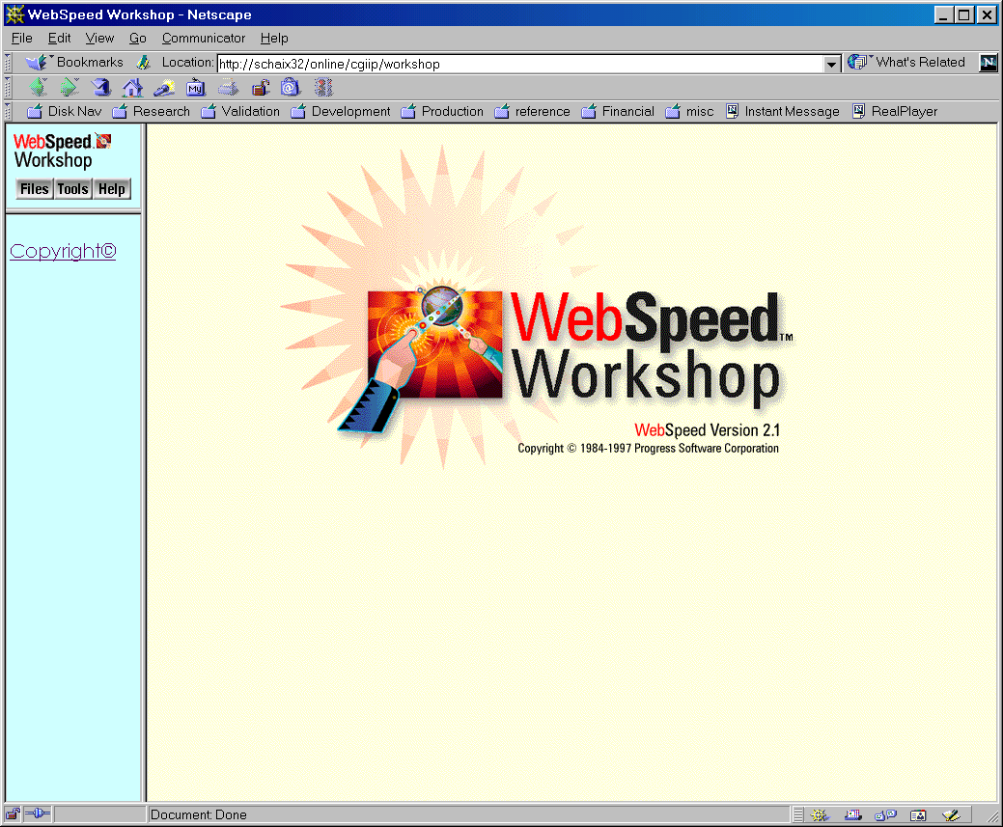

By using the Webspeed Workshop tool, the page can be connected to a database. This is done by adding 4GL code to it that allows the page to be dynamically generated based on database information by the transaction server. Once generated the data will be streamed to the web server via CGI or web server plug in to be passed back to the user’s browser.

The user would then click on links that would go to static pages, or to Webspeed generated pages requested by the webserver via CGI or web server plug in to the transaction server that would read inputs and interact with the database to create a new page to send back to the user.

The user can also fill in blanks available in a form on the page and send the page back to the webserver who would pass the information via CGI or web server plug in to the transaction server which can then deal with the inputs to place them in the database, validate against the database, or perform some kind of processing based on the data.
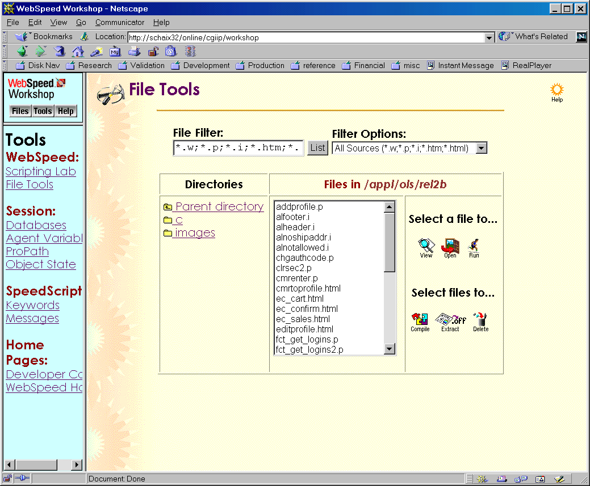

Once the file is in a location that can be accessed by the transaction server, Workshop, which uses the transaction server, can compile the program into a Webspeed program for execution by the Webspeed Transaction Server.

Progress programs have certain post-fixes attached to the name to designate the type of file it is:

.i – include file, similar to a C program include file.
.html – a webspeed E4GL program file.
.p – a Progress 4GL procedure file.
.r – a Progress 4GL or E4GL file compiled into byte code for execution by the transaction server.

Accessing the file after it is compiled by the server is by using an URL in a browser. The URL is composed of the machine name, CGI bin directory or plugin access, and then the file name of the Progress compiled file.

The presentation engine

General Theory of Operation

The presentation engine will create a static web site for the web server to provide to the browsers. The reason for this is to protect the number of transactions that will be asked of the agents. The more transactions asked of the agents, the more work the transaction server needs to do. The more work the transaction server needs to do, the more agents the provider of the catelog would require to handle the dynamic generation of web pages that can easily be served statically.

Creating the product page:

The directory structure for the presentation manager:

There are two main types of directories that the presentation manager works with. The most understood directory is the physical directories that reside on the disk. A newer directory concept is “virtual” directories that are used by web servers to help the user navigate the sets of web pages that are available.
The physical directories we are interested in are a base directory, and category directories that will be created automatically by the application. The base directory is the root directory for all the HTML pages and sub directories that will be created by the application.

/appl/catelog/static/html – a sample root directory
/appl/catelog/static/html/cat1 - directory path to products in category cat1
/appl/catelog/static/html/cat2 - directory path to products in category cat1
/appl/catelog/static/html/cat3 - directory path to products in category cat1

The virtual directories used by the presentation manager are the

The use of relational links within the presentation manager removes a concern about using the virtual directories for the

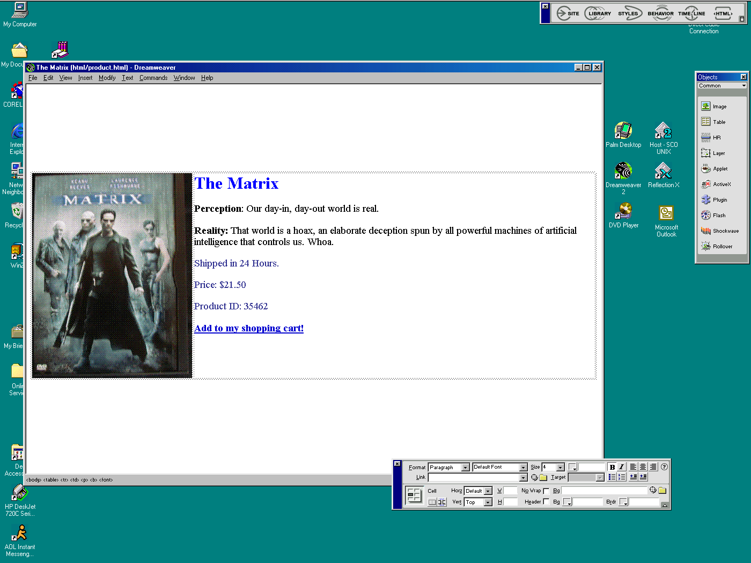

Using Dream Weaver to layout the Product Page main section.

<html>
<head>
<title>The Matrix</title>
<meta http-equiv="Content-Type" content="text/html; charset=iso-8859-1">
</head>

<body bgcolor="#FFFFFF">

<p>&nbsp;</p>
<p>&nbsp;</p>
<p>&nbsp;</p>
<p>&nbsp;</p>
<table width="100%" border="0">
<tr>
<td><img src="matrix.gif" width="298" height="382"></td>
<td valign="top">
<p><b><font size="6" color="#0000FF">The Matrix</font></b></p>
<p><font size="4"><b>Perception</b>: Our day-in, day-out world is real.</font></p>
<p><font size="4"><b>Reality:</b> That world is a hoax, an elaborate deception
spun by all powerful machines of artificial intelligence that controls
us. Whoa.</font></p>
<p><font color="#333399" size="4">Shipped in 24 Hours.</font></p>
<p><font color="#333399" size="4">Price: $21.50</font></p>
<p><font size="4" color="#333399">Product ID: 35462</font></p>
<p><b><font size="4"><a href="/webservice/inscart.html">Add to my shopping
cart!</a></font></b></p>
</td>
</tr>
</table>
</body>
</html>

HTML Code of the product page layout.

Script to turn HTML into something that can be outputted by the batch program

Conv.ksh

sed -e "s/^/\{\&STDOUT\} \'/" -e "s/$/\~n\'\./"

Invoked as:

Conv.ksh < product.html > product.p

Script to run the presentation engine:

Since the presentation engine is a background process that is run by the application administrator after the categories and products have been added, deleted, or modified, a command should be given for easy invocation of the program.

Presmng.ksh

export PROPATH=$PROPATH:/appl/webservice/src

$DLC/bin/mpro -b -pf /db/webservice/data/webservice.pf -p prsmngr/presmng.p

This code sets up the propath that the progress client will be using to find it’s program. Then the progress client is invoked with a PF file that will tell the client which database to connect to, as well as the buffering, temporary directory, etc. The final –p parameter instructs the client to execute the program named upon startup.

The script is set up for no human intervention to be required, so it can be schedules. Perhaps updates can happen during the day, and at night, the engine will re-work the static pages available in the web site.

Presentation Manager Source

Below is the presentation engine’s source,

/***************************************************************************
* Program: presmng.p *
***************************************************************************
* Author Date Description *
* s auge 12/06/99 Created *
***************************************************************************/

DEF VAR SCCS AS CHARACTER INIT "%Z% %I% %G% %U% %P%" NO-UNDO.

DEF BUFFER RootDirParm FOR Parm.
DEF BUFFER ImgDirParm FOR Parm.

/* Main portion of the program */

The use of special records called Parameter record help reduce the need to hard code such things as directories and constraints the application runs under. Having the data stored in the database also reduces the need to re-compile as the use of DEFINE pre-processor states would require.

The following statements are looking for the records that define where the categories and HTML pages are to be stored. The virtual image directory is also stored as a parameter. The images associated with the HTML pages are actually in a different physical directory with a differing virtual directory.

/* Determine root directory catelog should be in and create category */
/* directories as needed. */

FIND RootDirParm NO-LOCK
WHERE RootDirParm.Application = "presmng"
AND RootDirParm.Cluster = "1"
AND RootDirParm.Name = "rootdir"
NO-ERROR.

/* Cannot find the web server root directory for catelog */

IF NOT AVAILABLE RootDirParm THEN DO:

MESSAGE "Do not know where web server category root directory is...".
QUIT.

END.

FIND ImgDirParm NO-LOCK
WHERE ImgDirParm.Application = "presmng"
AND ImgDirParm.Cluster = "1"
AND ImgDirParm.Name = "imgdir"
NO-ERROR.

/* Cannot find the web server image directory for catelog */

IF NOT AVAILABLE ImgDirParm THEN DO:

MESSAGE "Do not know where web server category image directory is...".
QUIT.

END.

The creation of the subdirectories for each product of a given category is done in an internal procedure for modularization.

RUN mkcategoryhtml.

Once the physical directories have been created for the categories and the product HTML, go make the product HTML pages. This is also stored as an internal procedure for modularization.

/* Create the web pages for each product in each category */

RUN mkprodhtml.

/* We are done! */

The following are “internal procedures” for the Progress 4GL. They are very similar in nature to C sub-functions in idea. They can act as a means for modularization, as well to be repeatedly called when repeated actions and calculations need to be performed.

/* ---------------------- Internal Procedures ------------------------- */

This procedure calls another 4GL program to create the static pages that will act as pages that contain links for scrollers for each product in each of the categories. It also performs the UNIX operating system shell command to create the physical directories for the categories.

PROCEDURE mkcategoryhtml:

DEF VAR Command AS CHARACTER NO-UNDO.

/* Make the scrollers for the category */

RUN prsmngr/scrlcat.p (BUFFER RootDirParm).

/* Make the directories for the categories in the web server root */
/* directory. */

FOR EACH Category NO-LOCK:

ASSIGN Command = "mkdir "
+ RootDirParm.Data + "/"
+ Category.Name + " 2>/dev/null".
UNIX SILENT VALUE(Command).

END. /* FOR EACH Category */

END. /* PROCEDURE mkcategoryhtml */

The product pages and scrollers (which are static pages in the category directory with links to all the products in an index like form) are created with this module. The module calls an outside program to create the scrollers for each of the categories, and then calls the product HTML page creation routine discussed later in this section.

PROCEDURE mkprodhtml:

FOR EACH Category NO-LOCK:

/* Create a set of scrollers for products in the category. */

RUN prsmngr/scrlprod.p (BUFFER Category, BUFFER RootDirParm).

FOR EACH Product NO-LOCK
WHERE Product.CategoryID = Category.CategoryID:

RUN prsmngr/product.p (BUFFER Product,
BUFFER Category,
BUFFER RootDirParm,
BUFFER ImgDirParm).

END. /* FOR EACH Product */

END. /* FOR EACH Category */

END. /* PROCEDURE mkprodhtml */

Product.p

This program actually creates the page that the presentation manager wishes to generate. It is base off the HTML page that was developed for the product page look and feel.

The HTML page is then run through the conv.ksh script to add the apostrophies and STDOUT code to make the file from an HTML file into a Progress 4GL source code file. The this newly changed file has commenting and additional 4GL statements added to it to support being called from another program, as well to access the database, and to place the output into a specific disk file that can be used by the webserver.

/***************************************************************************
* Program: product.p *
***************************************************************************
* Author Date Description *
* s auge 12/06/99 Created *
***************************************************************************/

DEF VAR SCCS AS CHARACTER INIT "%Z% %I% %G% %U% %P%" NO-UNDO.
&GLOBAL-DEFINE STDOUT PUT STREAM OUT UNFORMATTED
DEF STREAM OUT.

The presentation manager calls this program program to actually render the pages as a file on the hard disk. The following buffers state the product record we are describing in the page, the category so that we can get the page into the correct directory off of what is described by pRootDir as the base disk directory we are going to put the HTML into, as well the virtual directory for the web browser to use to reach the images (images are stored in a different directory than the HTML).

DEF PARAMETER BUFFER pProduct FOR Product.
DEF PARAMETER BUFFER pCategory FOR Category.
DEF PARAMETER BUFFER pRootDir FOR Parm.
DEF PARAMETER BUFFER pImgDir FOR Parm.

DEF VAR FileName AS CHARACTER NO-UNDO.

Here we are figuring out where on the cmoputer’s hard disk we want to put the resulting HTML code from this program. It is a combination of a base directory (ie something like /appl/web/html), the category the product falls under, and finally what the HTML page name is (the product part.)

ASSIGN FileName = pRootDir.Data + "/"
+ pCategory.Name + "/"
+ pProduct.Part + ".html".

OUTPUT STREAM OUT TO VALUE(FileName) UNBUFFERED.

The following code with the {&STDOUT} was generated via the conv.ksh script mentioned earlier in this section. It saved a lot of “typing time” by prefixing the HTML with syntax that would allow the compiler to make a program out of it. After conv.ksh was run on the HTML, it was pasted into this file for additional editing to handle the display of the parameters buffers.

{&STDOUT} '<html>~n'.
{&STDOUT} '<head>~n'.
{&STDOUT} '<title>' pProduct.Name '</title>~n'.
{&STDOUT} '<meta http-equiv="Content-Type" content="text/html; charset=iso-8859-1">~n'.
{&STDOUT} '</head>~n'.
{&STDOUT} '~n'.
{&STDOUT} '<body bgcolor="#FFFFFF">~n'.
{&STDOUT} '~n'.

It has been found that it is easier to make an include file for HTML that is common on all the pages, and may be changed in the future for new company logos, additional navigation links, and new images.

{prsmngr/header.i}

{&STDOUT} '<table width="100%" border="0">~n'.
{&STDOUT} ' <tr>~n'.

/* Image and name for the product */

{&STDOUT} ' <td><img src="' pImgDir.Data + "/" + pProduct.Image '" width="298" height="382"></td>~n'.
{&STDOUT} ' <td valign="top">~n'.
{&STDOUT} ' <p><b><font size="6" color="#0000FF">' pProduct.Name '</font></b></p>~n'.

/* Product Description (Can be done in HTML) */

{&STDOUT} ' <p>' pProduct.Description '</p>~n'.

/* Product Logistic Details */

{&STDOUT} '<p><font color="#333399" size="4">Shipped in 24 Hours.</font></p>~n'.
{&STDOUT} '<p><font color="#333399" size="4">Price: $' pProduct.Price '</font></p>~n'.
{&STDOUT} '<p><font size="4" color="#333399">Product ID: ' pProduct.Part '</font></p>~n'.

The shopping cart module uses static links to manipulate the cart. One of the weaknesses is to note the price is used as a parameter. To actually use the shopping cart, the programmer should modify the shopping cart code (not this code) to reference the Product record to pull out the price from there, and not the hyperlink.

/* Link into shopping cart */

{&STDOUT} '<p><b><font size="4"><a href="/webservice/inscart.html?merchantid=0&item=' pProduct.Part '&qty=1&desc=' pProduct.BrfDescription '&price=' pProduct.Price '">Add to my shopping~n '.
{&STDOUT} ' cart!</a></font></b></p>~n'.
{&STDOUT} ' </td>~n'.
{&STDOUT} ' </tr>~n'.
{&STDOUT} '</table>~n'.

It has been found that it is easier to make an include file for HTML that is common on all the pages, and may be changed in the future for new company logos, additional navigation links, and new images.

{prsmngr/footer.i}

{&STDOUT} '</body>~n'.
{&STDOUT} '</html>~n'.

OUTPUT STREAM OUT CLOSE.

Header Code for all the pages

All the pages would have this code inserted into it as a common “header” for the page. Adding images, hyperlinks, and company logo’s or messages can be placed into this for one file editing convenience.

/***************************************************************************
* Program: header.i *
***************************************************************************
* Author Date Description *
* s auge 12/06/99 Created *
***************************************************************************/

{&STDOUT} '<p>Auge Emmons & Ziola, Inc. http://www.sauge.com/auge-emmons-ziola</p>~n'.
{&STDOUT} '<p>Electronic Catalog via Webspeed</p>~n'.
{&STDOUT} '<p>Prototype Version 1.2</p>~n'.

Footer Code for all the pages

Very similar in idea to the header file, but placed at the footer of the web pages.

/***************************************************************************
* Program: footer.i *
***************************************************************************
* Author Date Description *
* s auge 12/06/99 Created *
***************************************************************************/

{&STDOUT} '<center>~n'.
{&STDOUT} '<p>Written by Scott Auge Copyright December 1999</p>~n'.
{&STDOUT} '</center>~n'.

The category editor

Products within the electronic catalog can be aligned into different categories such as telephones, TVs, stereos, Women’s Clothes, Men’s Clothes, etc. It is the purpose of this screen to create the possible categories that the catalog will have available as well how to categorize products within the product editor.

The operation of the editor is very simple. Viewing the screen below, one can see that categories can be created, modified and deleted. To create a new category, the user enteris the Text of the category in the field next to the label “New Category” and presses the “Create Category” button.

To modify an existing category, the screen will come up with all the existing categories in the second part of the screen with the text of the category available for editing. To change the category, the user would enter the new name in the text field that contains the current name of the category. To commit the changes to the database, the user would click the “Save Changes” button.

To delete an existing category, the user would check the box in the same row as the category to be deleted and press the “Save Changes” button.

The user can modify the name of a categories, as well as delete other categories all in one shot.

Screen Image of Category Editor

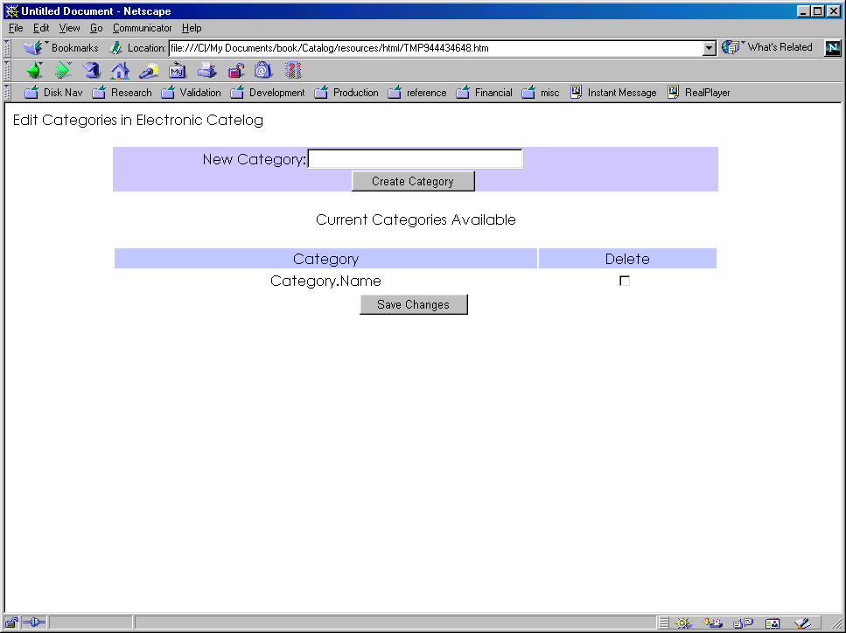

HTML Source from the editor

The following is HTML source code generated by Macromedia’s Dream Weaver product. It is here for reference.

<html>
<head>
<title>Edit Categories</title>
<meta http-equiv="Content-Type" content="text/html; charset=iso-8859-1">
</head>

<body bgcolor="#FFFFFF">
<p>Edit Categories in Electronic Catelog</p>
<form method="post" action="">
<table width="75%" border="0" cellpadding=" " cellspacing="0" align="center">
<tr bgcolor="#CCCCFF">
<td align="right">New Category:</td>
<td>
<input type="text" name="textfield" size="30">
</td>
</tr>
<tr align="center" bgcolor="#CCCCFF">
<td colspan="2">
<input type="submit" name="Submit" value="Create Category">
</td>
</tr>
</table>
<p align="center">Current Categories Available</p>
<table width="75%" border="0" align="center">
<tr bgcolor="#C8CCFF">
<td align="center">Category</td>
<td align="center">Delete</td>
</tr>
<tr>
<td align="center">Category.Name</td>
<td align="center">
<input type="checkbox" name="checkbox" value="checkbox">
</td>
</tr>
<tr>
<td align="center" colspan="2">
<input type="submit" name="Submit2" value="Save Changes">
</td>
</tr>
</table>
<p align="center">&nbsp;</p>
</form>
<p>&nbsp; </p>
</body>
</html>

Category editor Webspeed source after touch up with ES

<!--WSS
/***************************************************************************
* Program: editcat.html *
***************************************************************************
* Author Date Description *
* s auge 12/06/99 Created *
***************************************************************************/

Here a varible is defined so that data from the HTTP data stream can be manipulated at the 4GL level.

DEF VAR NewCategory AS CHARACTER NO-UNDO.

IF REQUEST_METHOD = “POST” THEN DO:

It is here that a new category is entered into the database. If the screen has sent a value in the text field “newcategory” then the program knows that the user is interested in creating a new record for a category. The program only allows the creation or updating of categories however.

ASSIGN NewCategory = GET-VALUE("newcategory").

/* Determine if we are making a new category */

IF NewCategory <> "" THEN DO:

CREATE Category.

ASSIGN
Category.CategoryID = NEXT-VALUE(CategoryID)
Category.Name = NewCategory.

END. /* NewCategory <> "" */

At this point we are modifying existing categories. This is in an else clause of an IF statement that determined if the user entered a value in the new category text field. If not, then the program executes the following code.

/* Modifying or adding - cant have both */

ELSE DO:

This section here determines if the categories are to be deleted. This is accomplished by naming the check boxes with del- and the category id of an existing record. This allows a one-to-one relationship between the check box and the record, and allows the program on the POST from the browser to relate the check-box back to the record. The loop then looks at the value of the check box from the HTTP data stream and determines if it should be deleted if it is checked.

/* Determine if we have any categories to delete */

FOR EACH Category EXCLUSIVE-LOCK:

IF GET-VALUE ("del-" + STRING(Category.CategoryID)) <> "" THEN
DELETE Category.

END. /* FOR EACH Category */

Since the page was drawn with the categoryID of each record as the name of the text field for the name of the category, the name can be directly related back to the record by looking into the HTTP data stream

/* Update the existing categories */

FOR EACH Category EXCLUSIVE-LOCK:

ASSIGN Category.Name = GET-VALUE(STRING(Category.CategoryID)).

END. /* FOR EACH Category */

END. /* ELSE */

END. /* REQUEST_METHOD = “POST” */

-->

After the database has been manipulated according to the instructions on the previous screen, the page is re-drawn with the new database information. On the first run of the program, the first time the page is brought up in the browser, the REQUEST_METHOD will be a GET, and not a POST. This will cause the above code to not execute at all, because it is blocked off with an IF statement, and the only code that will run in the code below, making a page with the current database data state.

<html>
<head>
<title>Edit Categories</title>
<meta http-equiv="Content-Type" content="text/html; charset=iso-8859-1">
</head>

<body bgcolor="#FFFFFF">
<p>Edit Categories in Electronic Catelog</p>
<form method="post">
<table width="75%" border="0" cellpadding=" " cellspacing="0" align="center">
<tr bgcolor="#CCCCFF">
<td align="right">New Category:</td>
<td>
<input type="text" name="newcategory" size="30">
</td>
</tr>
<tr align="center" bgcolor="#CCCCFF">
<td colspan="2">
<input type="submit" name="Submit" value="Create Category">
</td>
</tr>
</table>
<p align="center">Current Categories Available</p>
<table width="75%" border="0" align="center">
<tr bgcolor="#C8CCFF">
<td align="center">Category</td>
<td align="center">Delete</td>
</tr>

Here is additional Webspeed E4GL code that looks into the database for data and then creates HTML code to be sent to the browser.

<!--WSS
/* Display existing Categories */

FOR EACH Category NO-LOCK:
-->
<tr>
<td align="center"><input type="text" name="`Category.CategoryID`" value="`Category.Name`"></td>
<td align="center">
<input type="checkbox" name="del-`Category.CategoryID`" value="checkbox">
</td>
</tr>
<!--WSS
END. /* FOR EACH Category */
-->
<tr>
<td align="center" colspan="2">
<input type="submit" name="Submit2" value="Save Changes">
</td>
</tr>
</table>
<p align="center">&nbsp;</p>
</form>
<p>&nbsp; </p>
</body>
</html>

The Product Editor

In order to put products into the database that the presentation manager uses to create the catalog, the users need a tool to create products. The product editor as a whole is actually made up of multiple pages:

- A frames page that presents a menu area and a workspace area
- A page that presents the menu
- A page that allows creation of a product
- A page that allows deletions of products
- A page that allows modification of products

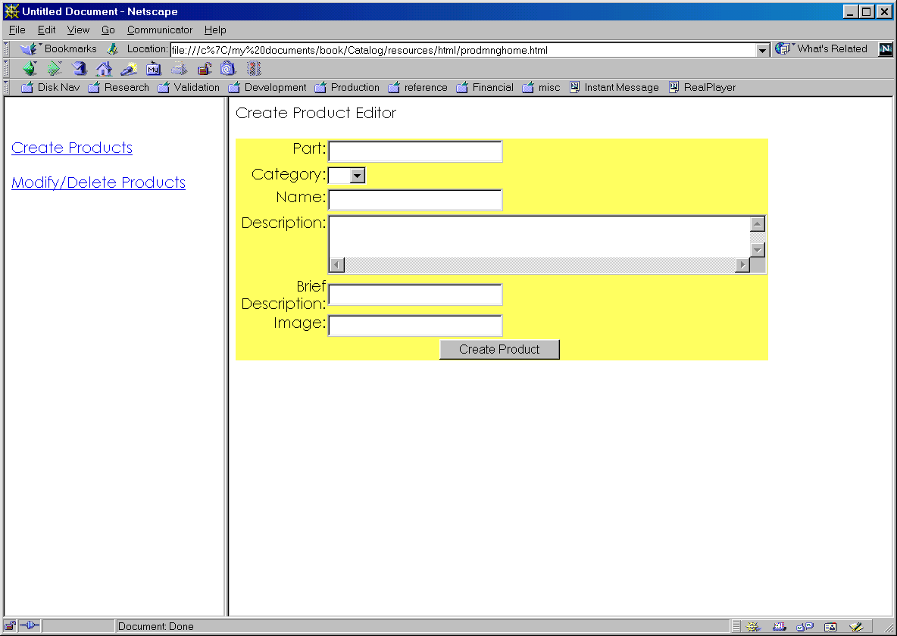

An example of a screen from the project editor showing the frames, menu, and creating a product page.

Main Menu for the Project Editor

This is actually an easy program to write, and can be a static page. One can compile it under Workshop and it will work just fine, but it will add unnecessary burden to your transaction server as it does nothing with the database. (Of course, one may want simplicity in one’s life and have the transaction server handle all the pages relevant to an application.)

<html>
<head>
<title>Product Manager Menu</title>
<meta http-equiv="Content-Type" content="text/html; charset=iso-8859-1">
</head>

<body bgcolor="#FFFFFF">

<p>&nbsp;</p>

Note that the HREFs do not need the machine name, but should use the cgi directory, messenger/plugin name, and program name. This is incase the page is called from a static page off the server. Also note the TARGET definitions, so that when the hyperlink is clicked, the output of the page is placed in a frame with this name, or a window is created with that name depending on the availability of the frame.

<p><a href="/online/prodmng/crtprod.html" target="workspace">Create Products</a></p>
<p><a href="/online/prodmng/modprod.html" target="workspace">Modify Products</a></p>
</body>
</html>

Putting the menu inside a framed webpage

In order to have a decent looking product manager, one could have the menu placed into a frame, with the pages that manipulate the database in another frame. Hyperlinks in the footers or headers of the product manipulation pages could accomplish the same thing, but here is a more complicated example:

<html>
<head>
<title>Untitled Document</title>
<meta http-equiv="Content-Type" content="text/html; charset=iso-8859-1">
</head>

Note how the frames are created. The user would call this page which would establish the frames, then the browser will look for the pages to populate the existing frames with and name the frames so hyperlinks and the like can use TARGET to get the page results in the correct frame.

<frameset cols="25%,75%" rows="*">
<frame src="prodmngmenu.html" name=”menu”>
<frame src="editprod.html" name=”workspace”>
</frameset>
<noframes><body bgcolor="#FFFFFF">

</body></noframes>
</html>

HTML for Create Product Editor

Once the basics have been established, pages need to be created that will manipulate the database by user interaction. This section discusses a page for the creation of products.

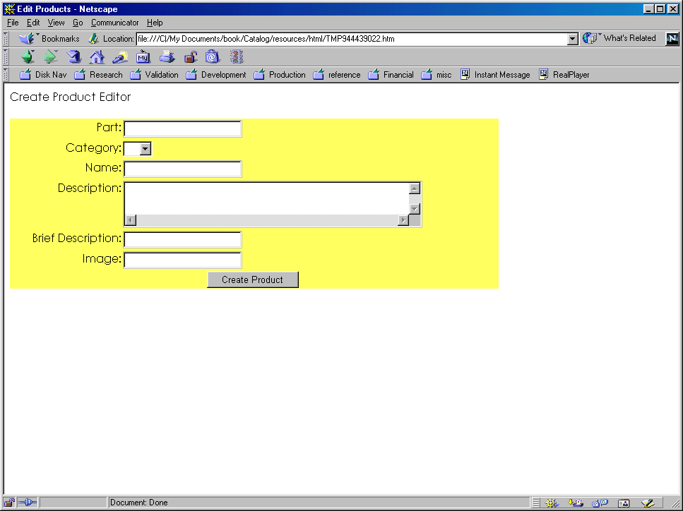

This is the HTML code created by MacroMedia’s Dream Weaver product. It is here for reference to see what it appears like before the E4GL goodies are added to it.

<html>
<head>
<title>Edit Products</title>
<meta http-equiv="Content-Type" content="text/html; charset=iso-8859-1">
</head>

<body bgcolor="#FFFFFF">
<p>Create Product Editor</p>
<form method="post" action="">
<table width="75%" border="0" cellspacing="0">
<tr bgcolor="#FFFF66">
<td align="right" valign="top">Part:</td>
<td>
<input type="text" name="part">
</td>
</tr>
<tr bgcolor="#FFFF66">
<td align="right" valign="top">Category:</td>
<td align="left">
<select name="category">
</select>
</td>
</tr>
<tr bgcolor="#FFFF66">
<td align="right" valign="top">Name:</td>
<td align="left">
<input type="text" name="name">
</td>
</tr>
<tr bgcolor="#FFFF66">
<td align="right" valign="top">Description:</td>
<td align="left">
<textarea name="description" cols="50" rows="2"></textarea>
</td>
</tr>
<tr bgcolor="#FFFF66">
<td align="right" valign="top">Brief Description:</td>
<td align="left">
<input type="text" name="brfdescription">
</td>
</tr>
<tr bgcolor="#FFFF66">
<td align="right" valign="top">Image:</td>
<td align="left">
<input type="text" name="image">
</td>
</tr>
<tr bgcolor="#FFFF66">
<td colspan="2" align="center">
<input type="submit" name="Submit" value="Create Product">
</td>
</tr>
</table>
<p>&nbsp;</p>
<p>&nbsp;</p>
</form>
<p>&nbsp; </p>
</body>
</html>

Webspeed code for Create Product Screen

<!--WSS
/***************************************************************************
* Program: crtprod.html *
***************************************************************************
* Author Date Description *
* s auge 12/06/99 Created *
***************************************************************************/

Here a set of variables are defined to store information coming in from the browser so that data is available to the 4GL.

DEF VAR lPart AS CHARACTER NO-UNDO.
DEF VAR lName AS CHARACTER NO-UNDO.
DEF VAR lDescription AS CHARACTER NO-UNDO.
DEF VAR lBrfDescription AS CHARACTER NO-UNDO.
DEF VAR lCategoryID AS CHARACTER NO-UNDO.
DEF VAR lImage AS CHARACTER NO-UNDO.

This is an include file with FUNCTION definitions used by the page. See Ancillary Code for more about this particular include file.

{common/errorbox.js}

The record creation code only works on a POST, that is the user clicked the Submit button on the form after it has been presented to them on the browser.

IF REQUEST_METHOD = "POST" THEN DO:

At this point, the program is taking information from the URL or from the fields in a form from the transmission stream of data sent to the web server by the browser and placing them into the above defined 4GL variables for manipulation by the 4GL.

ASSIGN
lPart = GET-VALUE("part")
lName = GET-VALUE("name")
lDescription = GET-VALUE("description")
lBrfDescription = GET-VALUE("brfdescription")
lCategoryID = GET-VALUE("categoryid")
lImage = GET-VALUE("image").

CREATE Product.

ASSIGN
Product.Part = lPart
Product.Name = lName
Product.Description = lDescription
Product.BrfDescription = lBrfDescription
Product.CategoryID = INTEGER(lCategoryID)
Product.Image = lImage.

Inform the user that the record was successfully created!

AlertBox ("Record Created Successfully!").

END.

-->

This is the code used to present the screen to the user before a new part is created, and after a new part is created. It does not have the ability to modify or delete an existing part.

<html>
<head>
<title>Create Products</title>
<meta http-equiv="Content-Type" content="text/html; charset=iso-8859-1">
</head>

<body bgcolor="#FFFFFF">
<p>Create Product Editor</p>
<form method="post">
<table width="75%" border="0" cellspacing="0">
<tr bgcolor="#FFFF66">
<td align="right" valign="top">Part:</td>
<td>
<input type="text" name="part">
</td>
</tr>
<tr bgcolor="#FFFF66">
<td align="right" valign="top">Category:</td>
<td align="left">

Here we are creating options within an drop down select box with values from the database. These values are made available through the category editor.

<select name="categoryid">
<!--WSS
FOR EACH Category NO-LOCK:
-->
<option value="`Category.CategoryID`">`Category.Name`</option>
<!--WSS
END. /* FOR EACH Category */
-->
</select>
</td>
</tr>
<tr bgcolor="#FFFF66">
<td align="right" valign="top">Name:</td>
<td align="left">
<input type="text" name="name">
</td>
</tr>
<tr bgcolor="#FFFF66">
<td align="right" valign="top">Description:</td>
<td align="left">
<textarea name="description" cols="50" rows="2"></textarea>
</td>
</tr>
<tr bgcolor="#FFFF66">
<td align="right" valign="top">Brief Description:</td>
<td align="left">
<input type="text" name="brfdescription">
</td>
</tr>
<tr bgcolor="#FFFF66">
<td align="right" valign="top">Image:</td>
<td align="left">
<input type="text" name="image">
</td>
</tr>
<tr bgcolor="#FFFF66">
<td colspan="2" align="center">
<input type="submit" name="Submit" value="Create Product">
</td>
</tr>
</table>
<p>&nbsp;</p>
<p>&nbsp;</p>
</form>
<p>&nbsp; </p>
</body>
</html>

The shopping cart

The shopping cart allows the tracking of what the customer wishes to purchase. It has functionality such as inserting and deleting items from the “basket,” identifying who the user is, as well the command to make the final purchase.

The cart does not do credit checking or any of the like however. Different merchant processing companies have different requirements to reach their systems in order to check the validity or process a credit card, and are therefore out of the scope of this book.

The shopping cart in this book supports more than one vendor – it was originally designed so that the catalog program could support more than on merchant who was using the software. Kind of like a Mall concept, of a group of merchants gathered together under one “roof” of the catalog program.

Be aware that there is a weakness with this shopping cart, as the price is not related back to a product record, but is part of the URL into the cart. It is possible for the user to save the HTML into a file, edit it, then reload it to the browser from the file, and post with the new price. Perhaps a project could be to change these sets of programs to use the product table to look up the price.

In designing the shopping cart, one needs to first figure out what business data one is going to need. Then to discover what kind of functionality is going to be asked for to manipulate that data.

The tables below describe the data that will be used:

Database tables involved in the shopping cart

Once the data has been established, things like inserting items into the cart will need to be defined. But before that can happen, the user would need to be made known to the system, a process called registration. After a user is known to the system, he or she may want to re-use the system without going thru the registration process again. That would be “logging into the system.” Once done, and to make sure no one can use their account on the system from their machine, they can “logout” of the system, making it unavailable to anyone using the computer/browser that just was using the system. Of course during the use of the system, the user may decide they really did not want that item, and would need to delete it from their shopping cart. Once the user is happy with what they have in their shopping cart, they would then need a place to inform the system they are ready to purchase the items.

All of these pieces of functionality are achieved with different pages within the system dedicated to that piece of processing needed to inform the system of the user’s desires.

While the pages output the same HTML page, with minor changes to the quantities and items available in the shopping cart, they actually are all different programs that manipulate the data in the data base in different ways. They then all call on another module of code to review the page to the user so that they can see what has changed in their shopping cart as it is represented in the database.

Registering the user

register.html?merchantid=[]&firstname=[]&lastname=[]&CCType=[]&CCExp=[]&CCNum=[]&Salute=[]&addr1=[]&addr2=[]&city=[]&state=[]&zip=[]&phone1=[]&phone2=[]

Registers a web user into the shopping cart service.

A page with a user id and a password will be returned to the web user.

A cookie will be deposited to the web user’s browser for sub-sequent use of the shopping cart service.

Arguments:

merchantid – identifier to a registered merchant
firstname – first name of the user
lastname – last name of the user
CCType – Type of credit card
CCExp – Expiration date of the credit card
CCNum – number of the credit card
Salute – perferred salutation to the user
addr1 – first line of postal address for the customer
addr2 – second line of postal address for the customer
city – city of the postal address for the customer
state – state of the postal address for the customer
zip – postal zip code for the address of the customer
phone1 – a phone number associated with the customer
phone2 – a phone number associated with the customer

<!--WSS
/***************************************************************************
* Program: register.p *
***************************************************************************
* Author Date Description *
* s auge 4/23/99 Created *
***************************************************************************/

DEF VAR SCCS AS CHARACTER NO-UNDO INIT "@(#) 1.1 5/5/99 20:28:18 /appl/webservice/src/sccs/s.register.html".

DEF VAR pMerchantID AS CHARACTER NO-UNDO.
DEF VAR lShopperID LIKE Shopper.ShopperID NO-UNDO.

Here a set of variables are defined to store information coming in from the browser so that data is available to the 4GL.

DEF VAR pFirstName AS CHARACTER NO-UNDO.
DEF VAR pLastName AS CHARACTER NO-UNDO.
DEF VAR pCCType AS CHARACTER NO-UNDO.
DEF VAR pCCExp AS CHARACTER NO-UNDO.
DEF VAR pCCNum AS CHARACTER NO-UNDO.
DEF VAR pSalute AS CHARACTER NO-UNDO.
DEF VAR pAddr1 AS CHARACTER NO-UNDO.
DEF VAR pAddr2 AS CHARACTER NO-UNDO.
DEF VAR pCity AS CHARACTER NO-UNDO.
DEF VAR pState AS CHARACTER NO-UNDO.
DEF VAR pZip AS CHARACTER NO-UNDO.
DEF VAR pPhone1 AS CHARACTER NO-UNDO.
DEF VAR pPhone2 AS CHARACTER NO-UNDO.
DEF VAR pPassWd AS CHARACTER NO-UNDO.
DEF VAR pValPasswd AS CHARACTER NO-UNDO.

This is an include file with FUNCTION definitions used by the page. See Ancillary Code for more about this particular include file.

{errorbox.js}

At this point, the program is taking information from the URL or from the fields in a form from the transmission stream of data sent to the web server by the browser and placing them into the above defined 4GL variables for manipulation by the 4GL.

ASSIGN

pMerchantID = GET-VALUE("merchantid")

pSalute = GET-VALUE("salute")
pFirstName = GET-VALUE("firstname")
pLastName = GET-VALUE("lastname")
pCCType = GET-VALUE("cctype")
pCCExp = GET-VALUE("ccexp")
pCCNum = GET-VALUE("ccnum")
pAddr1 = GET-VALUE("addr1")
pAddr2 = GET-VALUE("addr2")
pCity = GET-VALUE("city")
pState = GET-VALUE("state")
pZip = GET-VALUE("zip")
pPhone1 = GET-VALUE("phone1")
pPhone2 = GET-VALUE("phone2")
pPasswd = GET-VALUE("passwd")
pValPasswd = GET-VALUE("valpasswd").

One of the validations for this page, is to make sure the merchant the user is attempting to become a shopper of is actually available. The AlertBox() function is defined in the errorbox.js include file.

/* Determine if the merchant exists */

FIND Merchant NO-LOCK
WHERE Merchant.MerchantID = INTEGER(pMerchantID)
NO-ERROR.

IF NOT AVAILABLE Merchant THEN DO:

AlertBox("No such merchant account!").
RETURN.

END. /* No merchant found */

IF pPasswd <> pValPasswd THEN DO:

AlertBox("Password and Validation Password do not match").
RETURN.

END.

Now that we have the facts from the form or URL the user used to access this page with, lets do what the page is suppose to do – create a record to record pertinent shopper information as well to reference the shopper by. Use the 4GL to create a shopper record, call a program that generates a unique number to identify the shopper with, and assign to the record the variables containing the information we retrieved from the HTTP stream.

/* Create the shopper */

CREATE Shopper.

RUN genshopperid.p (OUTPUT lShopperID).

ASSIGN Shopper.ShopperID = lShopperID
Shopper.MerchantID = Merchant.MerchantID
Shopper.Salutation = pSalute
Shopper.FirstName = pFirstName
Shopper.LastName = pLastname
Shopper.CCType = pCCType
Shopper.CCNumber = pCCNum
Shopper.CCExpire = pCCExp
Shopper.PassWd = pPassWD.

Address information for the customer is kept in a separate database table, this is because future enhancements to the cart could be the ability to store differing billing and multiple shipping addresses. The record is related to the shopper with the Shopper.AddressID field.

/* Create the Address */

CREATE Address.

ASSIGN Address.AddressID = NEXT-VALUE(AddressID)
Address.Address1 = pAddr1
Address.Address2 = pAddr2
Address.City = pCity
Address.State = pState
Address.Zip = pZip
Address.Phone1 = pPhone1
Address.Phone2 = pPhone2.

ASSIGN Shopper.AddressID = Address.AddressID.

-->

Here we use HTML to let the user know how successful the registration process was. Note that in the bolded area, we are including mark up that uses the shopperid field from the new shopper record as output to the page.

<html>
<head>
<title>Registration Complete</title>
<meta http-equiv="Content-Type" content="text/html; charset=iso-8859-1">
</head>

<body bgcolor="#CCFFFF">
<h2><font color="#3333FF"><b>
<font face="Verdana, Arial, Helvetica, sans-serif" color="#3300CC">
Registeration is complete, please login!<br>
Your Shopper ID is `Shopper.ShopperID`<br>
Please write this down.
</font></b></font></h2>

</body>
</html>

Login the user

login.html?merchantid=[]&shopperid=[]&passwd=[]

Allows a user to login with an existing identification. Will deposit a cookie on the user’s browser to identify them to the service. The cookie will only last the lifetime of the browser instance. On successful login, will return a shopping cart screen.

If the user does not exist, the command will create the user.

Arguments:

merchantid – identifier to a registered merchant
shopperid – shopper’s userid from a previous register command
passwd – shopper’s password

<!--WSS
/***************************************************************************
* Program: login.p *
***************************************************************************
* Author Date Description *
* s auge 4/23/99 Created *
***************************************************************************/

DEF VAR SCCS AS CHARACTER NO-UNDO INIT "@(#) 1.3 5/5/99 22:06:13 /appl/webservice/src/sccs/s.login.html".

Here a set of variables are defined to store information coming in from the browser so that data is available to the 4GL.

DEF VAR pMerchantID AS CHARACTER NO-UNDO.
DEF VAR pUserID AS CHARACTER NO-UNDO.
DEF VAR pPassWD AS CHARACTER NO-UNDO.

DEF VAR lCartTotal AS DECIMAL NO-UNDO.
DEF VAR pAPIError AS CHARACTER NO-UNDO.

This is an include file with FUNCTION definitions used by the page. See Ancillary Code for more about this particular include file.

{errorbox.js}

The OUTPUT-HEADERS procedure is very important in the E4GL programming method of Webspeed as it allows processing to occur before the CONTENT TYPE portion of the HTTP protocol is out put to the user’s browser. Usually cookies are set before the CONTENT TYPE is defined and followed by the HTML or which ever kind of content is passed along to the user. If a cookie is attempted to be set after the CONTENT TYPE has been sent to the browser, the browser would merely show the instructions to make a cookie on the web page, and not accept the instructions to actually make a cookie.

PROCEDURE OUTPUT-HEADERS:

DEF VAR pMerchantID AS CHARACTER NO-UNDO.
DEF VAR pUserID AS CHARACTER NO-UNDO.
DEF VAR pPassWD AS CHARACTER NO-UNDO.

At this point, the program is taking information from the URL or from the fields in a form from the transmission stream of data sent to the web server by the browser and placing them into the above defined 4GL variables for manipulation by the 4GL.

ASSIGN pMerchantID = GET-VALUE("MerchantID")
pUserID = GET-VALUE("shopperid")
pPassWD = GET-VALUE("passwd").

/* Make sure we have all the facts, else say so */

IF pMerchantID = "" THEN ASSIGN pAPIError = "MerchantID missing".
IF pUserID = "" THEN ASSIGN pAPIError = "UserID missing".
IF pPasswd = "" THEN ASSIGN pAPIError = "PassWD missing".

Here we make sure the user is already a shopper. If not, then we will inform them of that later on in the program after all the tests have been performed to insure the user on the other end of the browser is who we think they are.

/* locate the shopper record, else say not available */

FIND Shopper NO-LOCK
WHERE Shopper.MerchantID = INTEGER(pMerchantID)
AND Shopper.ShopperID = INTEGER(pUserID)
NO-ERROR.

IF NOT AVAILABLE Shopper THEN ASSIGN pAPIError = "No Such Login" + pUserID.

We use cookies to place identifying information about the user onto the user’s browser. This way the browser can return data in a cookie that we know the name of and can look up information in the data base (that is the shopping cart tables) related to that user.

/* determine if password matches, else say bad password */

IF AVAILABLE Shopper
AND Shopper.Passwd <> pPasswd
THEN DO:

Right here we have realized the user has entered a bad password. We want to make doubly sure that the system is not available to this person by blanking out the shopperid cookie that may be resideing on their browser.

ASSIGN pAPIError = "Bad Password".
SET-COOKIE("shopperid", "", ?, ?, ?, ?, ?).
END.

At this point, we know we have a valid user, because their record was found in the database, and the user entered the correct password to identify themselves to the system with. Hence we populate the cookie with information that will allow us to reach their record in future calls to this interface so that we know who is contacting us.

/* Set the cookie */

ELSE
SET-COOKIE("shopperid", STRING(Shopper.ShopperID), ?, ?, "/", ".sauge.com", ?).

/* For the shopping cart to have the MerchantID in the hidden field "merchantid" */

FIND Merchant NO-LOCK
WHERE Merchant.MerchantID = INTEGER(pMerchantID)
NO-ERROR.

END. /* PROCEDURE OUTPUT-HEADERS */

At this point is where we determine if an error occurred – that is one of the validation rules failed or the like. We know this because the varible containing a message about an error occurring is populated with a string. The user is informed in an alertbox and execution of the program pretty much stops. (Note this does NOT stop the transaction server, it merely informs the transaction server not to execute THIS program any further.)

IF pAPIError <> "" THEN DO:

AlertBox (pAPIError).
RETURN.

END.

IF NOT AVAILABLE Shopper THEN DO:

AlertBox ("Shopper Not Logged In!").
RETURN.

END.

FIND Address OF Shopper NO-LOCK
NO-ERROR.

IF NOT AVAILABLE Address THEN DO:

AlertBox ("Shopper Adress not located!").
RETURN.

END. /* Address Not Found */

To keep the shopping cart looking the same for all these different pages that display it (the pages perform differing functions on the cart, but all return the cart in a page that appears the same), a common include file that has the HTML coding needed to display the page to the user.

{shoppingcart.w}

-->

Logout the user

<!--WSS
/***************************************************************************
* Program: logout.html *
***************************************************************************
* Author Date Description *
* s auge 5/06/99 Created *
***************************************************************************/

DEF VAR SCCS AS CHARACTER NO-UNDO INIT "@(#) 1.1 5/6/99 13:46:55 /appl/webservice/src/sccs/s.logout.html".

Here a set of variables are defined to store information coming in from the browser so that data is available to the 4GL.

DEF VAR pMerchantID AS CHARACTER NO-UNDO.
DEF VAR pUserID AS CHARACTER NO-UNDO.

DEF VAR pAPIError AS CHARACTER NO-UNDO.

This is an include file with FUNCTION definitions used by the page. See Ancillary Code for more about this particular include file.

{errorbox.js}

The OUTPUT-HEADERS procedure is very important in the E4GL programming method of Webspeed as it allows processing to occur before the CONTENT TYPE portion of the HTTP protocol is out put to the user’s browser. Usually cookies are set before the CONTENT TYPE is defined and followed by the HTML or which ever kind of content is passed along to the user. If a cookie is attempted to be set after the CONTENT TYPE has been sent to the browser, the browser would merely show the instructions to make a cookie on the web page, and not accept the instructions to actually make a cookie.

PROCEDURE OUTPUT-HEADERS:

Progress 4GL internal procedures allow the definition of variables local to the procedure.

DEF VAR pMerchantID AS CHARACTER NO-UNDO.
DEF VAR pUserID AS CHARACTER NO-UNDO.

At this point, the program is taking information from the URL or from the fields in a form from the transmission stream of data sent to the web server by the browser and placing them into the above defined 4GL variables for manipulation by the 4GL.

ASSIGN pMerchantID = GET-VALUE("MerchantID")
pUserID = GET-VALUE("shopperid").

/* Make sure we have all the facts, else say so */

IF pMerchantID = "" THEN ASSIGN pAPIError = "MerchantID missing".
IF pUserID = "" THEN ASSIGN pAPIError = "UserID missing".

/* locate the shopper record, else say not available */

FIND Shopper NO-LOCK
WHERE Shopper.MerchantID = INTEGER(pMerchantID)
AND Shopper.ShopperID = INTEGER(pUserID)
NO-ERROR.

IF NOT AVAILABLE Shopper THEN ASSIGN pAPIError = "No Such Login" + pUserID.

/* Set the cookie */
Right here is where we log out the shopper. This is because the cookie we use to identify them is set to a blank value – we do not have any information available to us from the browser in future calls to the programs making up the shopping cart because we have no way of relating the user of the browser to a record in the database.

ELSE
SET-COOKIE("shopperid", "", ?, ?, "/", ".sauge.com", ?).

END. /* PROCEDURE OUTPUT-HEADERS */

At this point is where we determine if an error occurred – that is one of the validation rules failed or the like. We know this because the varible containing a message about an error occurring is populated with a string. The user is informed in an alertbox and execution of the program pretty much stops. (Note this does NOT stop the transaction server, it merely informs the transaction server not to execute THIS program any further.)

IF pAPIError <> "" THEN DO:

AlertBox (pAPIError).
RETURN.

END.

IF NOT AVAILABLE Shopper THEN DO:

AlertBox ("Shopper Not Logged In!").
RETURN.

END.

-->

Here we inform the user that they have been logged off the system, and some details about the properties of their shopping basket should they log back into the system.

<html>
<head>
<title>Logout Complete</title>
<meta http-equiv="Content-Type" content="text/html; charset=iso-8859-1">
</head>

<body bgcolor="#CCFFFF">
<font color="#3333FF"><b>
<font face="Verdana, Arial, Helvetica, sans-serif" color="#3300CC">
You are now logged out. You will not be able to add<br>
items to your basket.<br>
Items not purchased will remain in your basket for next login.
</font></b></font>

</body>
</html>

Insert into shopping cart

inscart.html?merchantid=[]&item=[]&qty=[]&desc=[]&price=[]

Inserts a quantity of an item into the shopper’s cart. Returns a revised shopping cart screen.

If the Item already exists, the quantity on that record will be incremented by the amount in the qty argument.

Item and Qty will be placed into an E-Mail for the merchant to process the order once a purchase command has been placed by the user.

Command will use a cookie from the shopper’s browser to identify the shopper cart.

Arguments:

merchantid – identifier to a registered merchant
item – identification of the product to the merchant
qty – quantity of the item the shopper wishes to purchase.
desc – description of the item
price – Price of the item in a quantity of one

<!--WSS
/***************************************************************************
* Program: inscart.p *
***************************************************************************
* Author Date Description *
* s auge 4/23/99 Created *
***************************************************************************/

DEF VAR SCCS AS CHARACTER NO-UNDO INIT "@(#) 1.2 5/5/99 21:42:57 /appl/webservice/src/sccs/s.inscart.html".

Here a set of variables are defined to store information coming in from the browser so that data is available to the 4GL.

DEF VAR pShopperID AS CHARACTER NO-UNDO.
DEF VAR pMerchantID AS CHARACTER NO-UNDO.

DEF VAR pItem AS CHARACTER NO-UNDO.
DEF VAR pQty AS CHARACTER NO-UNDO.
DEF VAR pDescription AS CHARACTER NO-UNDO.
DEF VAR pPrice AS CHARACTER NO-UNDO.

DEF VAR lCartTotal AS DECIMAL NO-UNDO.

This is an include file with FUNCTION definitions used by the page. See Ancillary Code for more about this particular include file.

{errorbox.js}

/* see if we have a logged in shopper */

Read the cookie value from the cookie named shopperid. Make sure a shopper is logged in, and that the shopper is a registered shopper, else let the shopper know the system has no idea who they are.

ASSIGN pShopperID = GET-VALUE ("shopperid").

FIND Shopper NO-LOCK
WHERE Shopper.ShopperID = INTEGER(pShopperID)
NO-ERROR.

IF NOT AVAILABLE Shopper THEN DO:

AlertBox ("Shopper not logged in!").
RETURN.

END. /* Shopper not available */

Since the shopping cart is able to handle data from multiple merchants, we need to know which merchant this particular item is for.

/* look for the merchant in case the merchant has lapsed in subscription */

ASSIGN pMerchantID = GET-VALUE("merchantid").

FIND Merchant NO-LOCK
WHERE Merchant.MerchantID = INTEGER(pMerchantID)
NO-ERROR.

IF NOT AVAILABLE Merchant THEN DO:

AlertBox("Merchant not identified!").
RETURN.

END. /* Merchant not available */

/* Perform processing based on the submit button */

IF GET-VALUE("Submit") = "Update Qty" THEN DO:

{updqty.i}

END.

ELSE DO:
/* Determine if the item has been entered into the system already */

FIND CartHeader NO-LOCK
WHERE CartHeader.MerchantID = Merchant.MerchantID
AND CartHeader.ShopperID = Shopper.ShopperID
AND CartHeader.IsPurchased = NO
NO-ERROR.

IF NOT AVAILABLE CartHeader THEN DO:

CREATE CartHeader.

ASSIGN CartHeader.HeaderID = NEXT-VALUE (HeaderID)
CartHeader.MerchantID = Merchant.MerchantID
CartHeader.ShopperID = Shopper.ShopperID
CartHeader.IsPurchased = NO.

END. /* Making a new shopping cart */

At this point, the program is taking information from the URL or from the fields in a form from the transmission stream of data sent to the web server by the browser and placing them into the above defined 4GL variables for manipulation by the 4GL.

/* Determine if we are updating a line or making a new one. */
/* If updating, then we will add to the qty and refresh the */
/* price and description information. */

ASSIGN
pItem = GET-VALUE("item")
pDescription = GET-VALUE("description")
pPrice = GET-VALUE("price")
pQty = GET-VALUE("qty").

FIND CartLine OF CartHeader EXCLUSIVE-LOCK
WHERE CartLine.Item = pItem
NO-ERROR.

IF NOT AVAILABLE CartLine THEN CREATE CartLine.

ASSIGN CartLine.HeaderID = CartHeader.HeaderID
CartLine.Item = pItem
CartLine.Description = pDescription
CartLine.Qty = INTEGER (pQty) + CartLine.Qty
CartLine.Price = DECIMAL (pPrice).

END.

/* Return the revised shopping cart back to the user */

FIND Address OF Shopper NO-LOCK
NO-ERROR.

IF NOT AVAILABLE Address THEN DO:

AlertBox("Shopper has no address record!").
RETURN.

END. /* No Address for the shopper! */

To keep the shopping cart looking the same for all these different pages that display it (the pages perform differing functions on the cart, but all return the cart in a page that appears the same), a common include file that has the HTML coding needed to display the page to the user.

{shoppingcart.w}

-->

Delete from shopping cart

delcart.html?merchantid=[]&item=[]&qty=[]

Deletes a quantity of an item from the shopper’s cart. Returns a revised shopping cart screen.

If the Item already exists, the quantity on that record will be decremented by the amount in the qty argument.

If the item does not exist, the command will be ignored.

Item and Qty will be placed into an E-Mail for the merchant to process the order once a purchase command has been placed by the user.

Command will use a cookie from the shopper’s browser to identify the shopper cart.

Arguments:

merchantid – identifier to a registered merchant
item – identification of the product to the merchant
qty – quantity of the item the shopper wishes to remove.

<!--WSS
/***************************************************************************
* Program: delcart.p *
***************************************************************************
* Author Date Description *
* s auge 4/23/99 Created *
***************************************************************************/

DEF VAR SCCS AS CHARACTER NO-UNDO INIT "@(#) 1.2 5/5/99 21:42:16 /appl/webservice/src/sccs/s.delcart.html".

Here a set of variables are defined to store information coming in from the browser so that data is available to the 4GL.

DEF VAR pShopperID AS CHARACTER NO-UNDO.
DEF VAR pMerchantID AS CHARACTER NO-UNDO.

DEF VAR pItem AS CHARACTER NO-UNDO.
DEF VAR pQty AS CHARACTER NO-UNDO.

DEF VAR lCartTotal AS DECIMAL NO-UNDO.

This is an include file with FUNCTION definitions used by the page. See Ancillary Code for more about this particular include file.

{errorbox.js}

Here we are looking up the Shopper by the information from the browser cookie that was placed there when the user logged into the system. If the shopper record is not available – we inform the browser user and bail out.

/* see if we have a logged in shopper */

ASSIGN pShopperID = GET-VALUE ("shopperid").

FIND Shopper NO-LOCK
WHERE Shopper.ShopperID = INTEGER(pShopperID)
NO-ERROR.

IF NOT AVAILABLE Shopper THEN DO:

AlertBox ("Shopper not logged in!").
RETURN.

END. /* Shopper not available */

Since the shopping cart is able to handle data from multiple merchants, we need to know which merchant this particular item is for.

/* look for the merchant in case the merchant has lapsed in subscription */

ASSIGN pMerchantID = GET-VALUE("merchantid").

FIND Merchant NO-LOCK
WHERE Merchant.MerchantID = INTEGER(pMerchantID)
NO-ERROR.

IF NOT AVAILABLE Merchant THEN DO:

AlertBox("Merchant not identified!").
RETURN.

END. /* Merchant not available */

/* Perform processing based on the submit button */

IF GET-VALUE("Submit") = "Update Qty" THEN DO:

{updqty.i}

END.

ELSE DO:
/* Determine if the item has been entered into the system already */

FIND CartHeader NO-LOCK
WHERE CartHeader.MerchantID = Merchant.MerchantID
AND CartHeader.ShopperID = Shopper.ShopperID
AND CartHeader.IsPurchased = NO
NO-ERROR.

IF NOT AVAILABLE CartHeader THEN DO:

AlertBox("Nothing in Shopping Cart To Delete!").
RETURN.

END. /* Making a new shopping cart */

/* Determine if we are updating a line or making a new one. */
/* If updating, then we will add to the qty and refresh the */
/* price and description information. */

ASSIGN
pItem = GET-VALUE("item")
pQty = GET-VALUE("qty").

FIND CartLine OF CartHeader EXCLUSIVE-LOCK
WHERE CartLine.Item = pItem
NO-ERROR.

IF NOT AVAILABLE CartLine THEN DO:

AlertBox("You dont have that item!").

END.

ELSE DO:

ASSIGN CartLine.HeaderID = CartHeader.HeaderID
CartLine.Item = pItem
CartLine.Qty = CartLine.Qty - INTEGER (pQty).

IF CartLine.Qty <= 0 THEN DELETE CartLine.

END.

END.

/* Return the revised shopping cart back to the user */

FIND Address OF Shopper NO-LOCK
NO-ERROR.

IF NOT AVAILABLE Address THEN DO:

AlertBox("Shopper has no address record!").
RETURN.

END. /* No Address for the shopper! */

To keep the shopping cart looking the same for all these different pages that display it (the pages perform differing functions on the cart, but all return the cart in a page that appears the same), a common include file that has the HTML coding needed to display the page to the user.

{shoppingcart.w}

-->

Viewing the shopping cart

shwcart.html?merchantid=[]

Returns a revised shopping cart screen.

Command will use a cookie from the shopper’s browser to identify the shopper cart.

Arguments:

merchantid – identifier to a registered merchant

<!--WSS

/***************************************************************************
* Program: shwcart.p *
***************************************************************************
* Author Date Description *
* s auge 4/23/99 Created *
***************************************************************************/

DEF VAR SCCS AS CHARACTER NO-UNDO INIT "@(#) 1.2 5/5/99 21:42:39 /appl/webservice/src/sccs/s.shwcart.html".

Here a set of variables are defined to store information coming in from the browser so that data is available to the 4GL.

DEF VAR pShopperID AS CHARACTER NO-UNDO.
DEF VAR pMerchantID AS CHARACTER NO-UNDO.

DEF VAR lCartTotal AS DECIMAL NO-UNDO.

This is an include file with FUNCTION definitions used by the page. See Ancillary Code for more about this particular include file.

{errorbox.js}

At this point, the program is taking information from the URL or from the fields in a form from the transmission stream of data sent to the web server by the browser and placing them into the above defined 4GL variables for manipulation by the 4GL.

ASSIGN pShopperID = GET-VALUE("shopperid")
pMerchantID = GET-VALUE("merchantid").

Since the shopping cart is able to handle data from multiple merchants, we need to know which merchant this particular item is for.

FIND Merchant NO-LOCK
WHERE Merchant.MerchantID = INTEGER (pMerchantID)
NO-ERROR.

IF NOT AVAILABLE Merchant THEN DO:

AlertBox("No Merchant registered!").
RETURN.

END.

Here we are looking up the Shopper by the information from the browser cookie that was placed there when the user logged into the system. If the shopper record is not available – we inform the browser user and bail out.

FIND Shopper OF Merchant NO-LOCK
WHERE Shopper.ShopperID = INTEGER(pShopperID)
NO-ERROR.

IF NOT AVAILABLE Shopper THEN DO:

AlertBox("No Shopper Logged in!").
RETURN.

END.

/* Perform processing based on the submit button */

IF GET-VALUE("Submit") = "Update Qty" THEN DO:

{updqty.i}

END.

FIND Address OF Shopper NO-LOCK
NO-ERROR.

IF NOT AVAILABLE Address THEN DO:

AlertBox("No Address For Shopper!").
RETURN.

END.

To keep the shopping cart looking the same for all these different pages that display it (the pages perform differing functions on the cart, but all return the cart in a page that appears the same), a common include file that has the HTML coding needed to display the page to the user.

{shoppingcart.w}

-->

Make the purchase

purchase.html?merchantid=[]

Commits the shopping cart into an order and an email will be sent out immediately to the merchant subscriber detailing the shopping cart’s contents.

Command will use a cookie from the shopper’s browser to identify the shopper cart.

Arguments:

merchantid – identifier to a registered merchant

<!--WSS
/***************************************************************************
* Program: purchase.p *
***************************************************************************
* Author Date Description *
* s auge 4/23/99 Created *
***************************************************************************/

DEF VAR SCCS AS CHARACTER NO-UNDO INIT "@(#) 1.1 5/5/99 20:28:17 /appl/webservice/src/s.purchase.html".

Here a set of variables are defined to store information coming in from the browser so that data is available to the 4GL.

DEF VAR pMerchantID AS CHARACTER NO-UNDO.
DEF VAR pShopperID AS CHARACTER NO-UNDO.

{errorbox.js}

At this point, the program is taking information from the URL or from the fields in a form from the transmission stream of data sent to the web server by the browser and placing them into the above defined 4GL variables for manipulation by the 4GL.

ASSIGN pMerchantID = GET-VALUE("merchantid")
pShopperID = GET-VALUE("shopperid").

Since the shopping cart is able to handle data from multiple merchants, we need to know which merchant this particular item is for.

FIND Merchant NO-LOCK
WHERE Merchant.MerchantID = INTEGER(pMerchantID)
NO-ERROR.

IF NOT AVAILABLE Merchant THEN DO:

AlertBox("No Merchant Account!").
RETURN.

END.

Here we are looking up the Shopper by the information from the browser cookie that was placed there when the user logged into the system. If the shopper record is not available – we inform the browser user and bail out.

FIND Shopper OF Merchant NO-LOCK
WHERE Shopper.ShopperID = INTEGER(pShopperID)
NO-ERROR.

IF NOT AVAILABLE Shopper THEN DO:

AlertBox("No Shopper Account!").
RETURN.

END.

/* These two finds tell us if there is anything in the shopping cart */

FIND CartHeader NO-LOCK
WHERE CartHeader.MerchantID = Merchant.MerchantID
AND CartHeader.ShopperID = Shopper.ShopperID
AND CartHeader.IsPurchased = NO
NO-ERROR.

IF AVAILABLE CartHeader THEN
FIND FIRST CartLine OF CartHeader NO-LOCK
NO-ERROR.

IF AVAILABLE CartLine THEN DO:

/* Construct the email messsage */

RUN mkemail.p (INPUT Merchant.MerchantID,
INPUT Shopper.ShopperID).

END. /* Have something in cart to buy */

-->

Here we inform the user that they have indeed purchased the items in their shopping cart.

<html>
<head>
<title>Thank you for your purchase! </title>
<meta http-equiv="Content-Type" content="text/html; charset=iso-8859-1">
</head>

<body bgcolor="#FFFFFF">
<h2><font color="#3333FF"><b>
<font face="Verdana, Arial, Helvetica, sans-serif" color="#3300CC">

<!--WSS
IF AVAILABLE CartLine THEN DO:
-->
Thank you for your purchase!
<!--WSS
END.

ELSE DO:
-->
Nothing in your cart to purchase!
<!--WSS
END.
-->

</font></b></font>
</body>
</html>

Ancillary Code

Errorbox.js

This code will output to the browser Javascript code that can be called upon when as error occurred. It is basically using the Progress 4GL to create Javascript code within HTML code.

/* @(#) 1.1 5/5/99 20:28:37 /appl/webservice/src/s.errorbox.js */
FUNCTION AlertBox RETURNS LOGICAL (INPUT p_Msg AS CHARACTER):

{&OUT}
'~<script language="JavaScript"~>~n'
'window.alert("' p_Msg '");~n'
'~</script~>~n'.
RETURN TRUE.

END FUNCTION. /* AlertBox */

FUNCTION ErrorBox RETURNS LOGICAL (INPUT p_Msg AS CHARACTER):

{&OUT}
'~<script language="JavaScript"~>~n'
'window.alert("' p_Msg '");~n'
'history.back();~n'
'~</script~>~n'.
RETURN TRUE.

END FUNCTION. /* ErrorBox */

Genshopperid.p

This module of code makes a call to UNIX and asks it to run a program called mkid found in the /usr/local/bin directory. It retrieves the output of this to a varible that is sent back to the calling program.

The shopperID is a mix of numbers in non-sequential order. This is so it is harder for the user to manipulate their ID string to order as a different user.

DEF OUTPUT PARAMETER pShopperID LIKE Shopper.ShopperID NO-UNDO.

DEF STREAM OSStream.

DEF VAR SCCS AS CHARACTER NO-UNDO INIT "@(#) 1.1 5/5/99 20:28:17 /appl/webservice/src/s.genshopperid.p".

INPUT STREAM OSStream THRU /usr/local/bin/mkid.
SET STREAM OSStream pShopperID FORMAT "(>>>>>>>>>>>>>9)".
INPUT STREAM OSStream CLOSE.

Updqty.i

This code is common to the shopping cart insertion and deletion function pages. Hence to keep the table manipulations common, they are stored in an include file so that quantity rule changes are immediately available to the shopping cart quantity manipulation pages.

/*************************************************************************
* file: updqty.i *
* *
* Performs the update qty" function of the shopping cart "submit" *
* button. *
* Expects the varibles pMerchantID and pShopperID to be available as *
* character. *
* Needs to be in an E4GL source module as it uses GET-VALUE(). *
* Should be an include to the E4GL module. *
*************************************************************************/

DEF VAR SCCS_updqty AS CHARACTER INIT "@(#) 1.1 5/5/99 21:43:20 /appl/webservice/src/sccs/s.updqty.i" NO-UNDO.

FIND CartHeader NO-LOCK
WHERE CartHeader.ShopperID = INTEGER(pShopperID)
AND CartHeader.MerchantID = INTEGER(pMerchantID)
AND CartHeader.IsPurchased = NO
NO-ERROR.

IF AVAILABLE CartHeader THEN DO:

FOR EACH CartLine OF CartHeader EXCLUSIVE-LOCK:

ASSIGN CartLine.Qty = INTEGER(GET-VALUE(STRING(ROWID(CartLine)))).

IF CartLine.Qty = 0 THEN DELETE CartLine.

END. /* FOR EACH CartLine OF CartHeader */

END. /* AVAILABLE CartHeader */

Shoppingcart.w

DEF VAR SCCS_shoppingcart AS CHARACTER NO-UNDO INIT "@(#) 1.4 5/6/99 18:15:50 /appl/webservice/src/sccs/s.shoppingcart.w".
{&OUT} '<html>~n'.
{&OUT} '<head>~n'.
{&OUT} '<title>Shopping Cart</title>~n'.
{&OUT} '<!-- E4GL Disabled: meta http-equiv="Content-Type" content="text/html~; charset=iso-8859-1" -->~n'.
{&OUT} '</head>~n'.

{&OUT} '<body bgcolor="#CCFFFF">~n'.
{&OUT} '<h2><font color="#3333FF"><b><font face="Verdana, Arial, Helvetica, sans-serif" color="#3300CC">Shopping ~n'.
{&OUT} ' Cart</font></b></font></h2>~n'.
{&OUT} '<p><font face="Verdana, Arial, Helvetica, sans-serif" color="#3300CC">' /*Tag=`*/ Shopper.Salutation /*Tag=`*/ ' &nbsp~; ' /*Tag=`*/ Shopper.FirstName /*Tag=`*/ ' &nbsp~; ' /*Tag=`*/ Shopper.LastName /*Tag=`*/ '<br>~n'.
{&OUT} /*Tag=`*/ Address.Address1 /*Tag=`*/ '<br>~n'.
{&OUT} /*Tag=`*/ Address.Address2 /*Tag=`*/ '<br>~n'.
{&OUT} /*Tag=`*/ Address.City /*Tag=`*/ ', ' /*Tag=`*/ Address.State /*Tag=`*/ ' &nbsp~; ' /*Tag=`*/ Address.Zip /*Tag=`*/ '<br>~n'.
{&OUT} ' ' Address.Phone1 '</font></p>~n'.
{&OUT} '<form method="post" action="/gen/webservice/inscart.html">~n'.
/* Commented out cuz wont work in login.html */
/* {&OUT} '<form method="post" action="' SelfURL '">~n'. */
{&OUT} '<input type="hidden" name="merchantid" value="' STRING(Merchant.MerchantID) '">~n'.
{&OUT} '<table width="100%" border="1">~n'.
{&OUT} ' <tr align="center" bgcolor="#CCCCFF"> ~n'.
{&OUT} ' <td><font color="#3333FF"><b><font face="Verdana, Arial, Helvetica, sans-serif" color="#3300CC">Item</font></b></font></td>~n'.
{&OUT} ' <td><font color="#3333FF"><b><font face="Verdana, Arial, Helvetica, sans-serif" color="#3300CC">Description</font></b></font></td>~n'.
{&OUT} ' <td><font color="#3333FF"><b><font face="Verdana, Arial, Helvetica, sans-serif" color="#3300CC">Qty</font></b></font></td>~n'.
{&OUT} ' <td><font color="#3333FF"><b><font face="Verdana, Arial, Helvetica, sans-serif" color="#3300CC">Price</font></b></font></td>~n'.
{&OUT} ' <td><font color="#3333FF"><b><font face="Verdana, Arial, Helvetica, sans-serif" color="#3300CC">Total</font></b></font></td>~n'.
{&OUT} ' </tr>~n'.

/*Tag=<!--WSS*/

FIND CartHeader OF Shopper
WHERE CartHeader.IsPurchased = NO
NO-LOCK NO-ERROR.

FOR EACH CartLine OF CartHeader NO-LOCK:

/*Tag=-->*/

{&OUT} ' <tr bgcolor="#FFFF99"> ~n'.
{&OUT} ' <td align="center">~n'.
{&OUT} ' <font color="#3333FF"><b><font face="Verdana, Arial, Helvetica, sans-serif" color="#3300CC">~n'.
{&OUT} /*Tag=`*/ CartLine.Item /*Tag=`*/ '</font></b></font>~n'.
{&OUT} ' </td>~n'.
{&OUT} ' <td align="center">~n'.
{&OUT} ' <font color="#3333FF"><b><font face="Verdana, Arial, Helvetica, sans-serif" color="#3300CC">~n'.
{&OUT} /*Tag=`*/ CartLine.Description /*Tag=`*/ '</font></b></font></td>~n'.
{&OUT} ' <td align="center">~n'.
{&OUT} ' <font color="#3333FF"><b><font face="Verdana, Arial, Helvetica, sans-serif" color="#3300CC">~n'.
{&OUT} /*Tag=`*/'<input type="text" size="3" name="'STRING(ROWID(CartLine))'" value="' CartLine.Qty /*Tag=`*/ '"></font></b></font></td>~n'.
{&OUT} ' <td align="center">~n'.
{&OUT} ' <font color="#3333FF"><b><font face="Verdana, Arial, Helvetica, sans-serif" color="#3300CC">~n'.
{&OUT} /*Tag=`*/ CartLine.Price format ">>,>>9.99" /*Tag=`*/ '</font></b></font></td>~n'.
{&OUT} ' <td align="center">~n'.
{&OUT} ' <font color="#3333FF"><b><font face="Verdana, Arial, Helvetica, sans-serif" color="#3300CC">~n'.
{&OUT} /*Tag=`*/ CartLine.Qty * CartLine.Price format ">>,>>9.99" /*Tag=`*/ '</font></b></font></td>~n'.
{&OUT} ' </tr>~n'.

/*Tag=<!--WSS*/

ASSIGN lCartTotal = lCartTotal + CartLine.Qty * CartLine.Price.

END. /* FOR EACH CartLine OF CartHeader */
/*Tag=-->*/

{&OUT} ' <tr> ~n'.
{&OUT} ' <td colspan="4" align="right" bgcolor="#CCCCFF">~n'.
{&OUT} ' <font color="#3333FF"><b><font face="Verdana, Arial, Helvetica, sans-serif" color="#3300CC">Shopping ~n'.
{&OUT} ' Total </font></b></font></td>~n'.
{&OUT} ' <td bgcolor="#FFFF99" align="center">~n'.
{&OUT} ' <font color="#3333FF"><b><font face="Verdana, Arial, Helvetica, sans-serif" color="#3300CC">~n'.
{&OUT} /*Tag=`*/ lCartTotal format ">>,>>9.99" /*Tag=`*/ .
{&OUT} ' </font></b></font>~n'.
{&OUT} ' </td>~n'.
{&OUT} ' </tr>~n'.
{&OUT} '</table>~n'.
{&OUT} '<p><center><input type="submit" name="submit" value="Update Qty"></center></p>'.
{&OUT} '</form>~n'.

{&OUT} '<form method="post" action="/gen/webservice/purchase.html">'.
{&OUT} '<input type="hidden" name="merchantid" value="' Merchant.MerchantID '">'.
{&OUT} '<table>'.
{&OUT} '<tr align="center">'.
{&OUT} '<center><input type="submit" name="submit" value="Purchase"></center>'.
{&OUT} '</tr>'.
{&OUT} '</table>'.

{&OUT} '</form>'.

{&OUT} '<p>&nbsp~;</p>~n'.
{&OUT} '<p>&nbsp~; </p>~n'.
{&OUT} '</body>~n'.
{&OUT} '</html>~n'.

/* end */

Appendix A

Data Table Definitions:

12/05/99 17:18:55 PROGRESS Report
Database: /db/webservice/data/webservice (PROGRESS)

Table Name Description
----------------------------------------------------------------------------
Address Addresses within the application
CartHeader Header record for a shopping cart
CartLine Items in the shopping cart
Category Categories of products
Merchant Merchants scubscribing to the service
parm Parameters for program operation
Product Products available within the catelog
Shopper Shoppers within the system

=========================================================================
============================= Table: Address ============================

Table Flags: "f" = frozen, "s" = a SQL table

Table Dump Table Field Index Table
Name Name Flags Count Count Label
----------------------------- -------- ----- ----- ----- -------------------
Address address 8 1 ?

============================= FIELD SUMMARY =============================
============================= Table: Address ============================

Flags: <c>ase sensitive, <i>ndex component, <m>andatory, <v>iew component

Order Field Name Data Type Flags Format Initial
----- ------------------------- ----------- ----- --------------- ----------
10 AddressID inte i ->,>>>,>>9 0
20 Address1 char x(8)
30 Address2 char x(8)
40 City char x(8)
50 State char x(8)
60 Zip char x(8)
70 Phone1 char x(8)
80 Phone2 char x(8)

Field Name Label Column Label
------------------------------ ---------------------- ----------------------
AddressID AddressID AddressID
Address1 Address1 Address1
Address2 Address2 Address2
City City City
State State State
Zip Zip Zip
Phone1 Phone1 Phone1
Phone2 Phone2 Phone2

============================= INDEX SUMMARY =============================
============================= Table: Address ============================

Flags: <p>rimary, <u>nique, <w>ord, <a>bbreviated, <i>nactive, + asc, - desc

Flags Index Name Cnt Field Name
----- -------------------------------- --- ---------------------------------
pu pukey 1 + AddressID

============================= FIELD DETAILS =============================
============================= Table: Address ============================

** Field Name: AddressID
Description: Surrogate Key Primary Unique
Help: Surrogate Key Primary Unique

** Field Name: Address1
Description: Address One
Help: Address One

** Field Name: Address2
Description: Address Two
Help: Address Two

** Field Name: City
Description: City
Help: City

** Field Name: State
Description: State
Help: State

** Field Name: Zip
Description: Zip
Help: Zip

** Field Name: Phone1
Description: Phone One
Help: Phone One

** Field Name: Phone2
Description: Phone Two
Help: Phone Two

=========================================================================
============================= Table: CartHeader =========================

Table Flags: "f" = frozen, "s" = a SQL table

Table Dump Table Field Index Table
Name Name Flags Count Count Label
----------------------------- -------- ----- ----- ----- -------------------
CartHeader carthead 6 2 ?

============================= FIELD SUMMARY =============================
============================= Table: CartHeader =========================

Flags: <c>ase sensitive, <i>ndex component, <m>andatory, <v>iew component

Order Field Name Data Type Flags Format Initial
----- ------------------------- ----------- ----- --------------- ----------
10 MerchantID inte i ->,>>>,>>9 0
20 ShopperID inte i ->,>>>,>>9 0
30 HeaderID inte i ->,>>>,>>9 0
40 PurchaseDate date 99/99/99 ?
50 PurchaseTime inte ->,>>>,>>9 0
60 IsPurchased logi yes/no no

Field Name Label Column Label
------------------------------ ---------------------- ----------------------
MerchantID MerchantID MerchantID
ShopperID ShopperID ShopperID
HeaderID HeaderID HeaderID
PurchaseDate PurchaseDate Purchase!Date
PurchaseTime PurchaseTime Purchase!Time
IsPurchased IsPurchased IsPurchased

============================= INDEX SUMMARY =============================
============================= Table: CartHeader =========================

Flags: <p>rimary, <u>nique, <w>ord, <a>bbreviated, <i>nactive, + asc, - desc

Flags Index Name Cnt Field Name
----- -------------------------------- --- ---------------------------------
u headerid 1 + HeaderID

pu pukey 3 + MerchantID
+ ShopperID
+ HeaderID

============================= FIELD DETAILS =============================
============================= Table: CartHeader =========================

** Field Name: MerchantID
Description: Surrogate Key Primary Unique
Help: Surrogate Key Primary Unique

** Field Name: ShopperID
Description: Surrogate Key Primary Unique
Help: Surrogate Key Primary Unique

** Field Name: HeaderID
Description: Surrogate Key Primary Unique
Help: Surrogate Key Primary Unique

** Field Name: PurchaseDate
Description: Purchase date for contents of shopping cart
Help: Purchase date for contents of shopping cart

** Field Name: PurchaseTime
Description: Purchase time of shopping cart contents
Help: Purchase time of shopping cart contents

** Field Name: IsPurchased
Description: Flag stating contents purchased
Help: Flag stating contents purchased

=========================================================================
============================= Table: CartLine ===========================

Table Flags: "f" = frozen, "s" = a SQL table

Table Dump Table Field Index Table
Name Name Flags Count Count Label
----------------------------- -------- ----- ----- ----- -------------------
CartLine cartline 5 1 ?

============================= FIELD SUMMARY =============================
============================= Table: CartLine ===========================

Flags: <c>ase sensitive, <i>ndex component, <m>andatory, <v>iew component

Order Field Name Data Type Flags Format Initial
----- ------------------------- ----------- ----- --------------- ----------
30 HeaderID inte i ->,>>>,>>9 0
40 Qty inte ->,>>>,>>9 0
50 Item char x(8)
60 Description char x(8)
70 Price deci-2 ->>,>>9.99 0

Field Name Label Column Label
------------------------------ ---------------------- ----------------------
HeaderID HeaderID HeaderID
Qty Qty Qty
Item Item Item
Description Description Description
Price Price Price

============================= INDEX SUMMARY =============================
============================= Table: CartLine ===========================

Flags: <p>rimary, <u>nique, <w>ord, <a>bbreviated, <i>nactive, + asc, - desc

Flags Index Name Cnt Field Name
----- -------------------------------- --- ---------------------------------
p pukey 1 + HeaderID

============================= FIELD DETAILS =============================
============================= Table: CartLine ===========================

** Field Name: HeaderID
Description: Surrogate Key Primary Unique
Help: Surrogate Key Primary Unique

** Field Name: Qty
Description: Quantity of item in shopping cart
Help: Quantity of item in shopping cart

** Field Name: Item
Description: Stocking Unit Number Of Item
Help: Stocking Unit Number Of Item

** Field Name: Description
Description: Description of item
Help: Description of item

** Field Name: Price
Description: Price of one qty of item
Help: Price of one qty of item

=========================================================================
============================= Table: Category ===========================

Table Flags: "f" = frozen, "s" = a SQL table

Table Dump Table Field Index Table
Name Name Flags Count Count Label
----------------------------- -------- ----- ----- ----- -------------------
Category category 3 1 Category

============================= FIELD SUMMARY =============================
============================= Table: Category ===========================

Flags: <c>ase sensitive, <i>ndex component, <m>andatory, <v>iew component

Order Field Name Data Type Flags Format Initial
----- ------------------------- ----------- ----- --------------- ----------
10 CategoryID inte ->,>>>,>>9 0
20 Name char x(8)
30 Order inte ->,>>>,>>9 0

Field Name Label Column Label
------------------------------ ---------------------- ----------------------
CategoryID CategoryID CategoryID
Name Name Name
Order Order Order

============================= INDEX SUMMARY =============================
============================= Table: Category ===========================

Flags: <p>rimary, <u>nique, <w>ord, <a>bbreviated, <i>nactive, + asc, - desc

Flags Index Name Cnt Field Name
----- -------------------------------- --- ---------------------------------
p default 0

============================= FIELD DETAILS =============================
============================= Table: Category ===========================

** Field Name: CategoryID
Description: Unique identification for category
Help: Unique identification for category

** Field Name: Name
Description: Name of category
Help: Name of category

** Field Name: Order
Description: Order Categories shown in scrl page
Help: Order Categories shown in scrl page

=========================================================================
============================= Table: Merchant ===========================

Table Flags: "f" = frozen, "s" = a SQL table

Table Dump Table Field Index Table
Name Name Flags Count Count Label
----------------------------- -------- ----- ----- ----- -------------------
Merchant merchant 4 1 ?

============================= FIELD SUMMARY =============================
============================= Table: Merchant ===========================

Flags: <c>ase sensitive, <i>ndex component, <m>andatory, <v>iew component

Order Field Name Data Type Flags Format Initial
----- ------------------------- ----------- ----- --------------- ----------
10 MerchantID inte i ->,>>>,>>9 0
20 EMail char x(8)
30 AddressID inte ->,>>>,>>9 0
40 Name char x(8)

Field Name Label Column Label
------------------------------ ---------------------- ----------------------
MerchantID MerchantID MerchantID
EMail EMail EMail
AddressID AddressID AddressID
Name Name Name

============================= INDEX SUMMARY =============================
============================= Table: Merchant ===========================

Flags: <p>rimary, <u>nique, <w>ord, <a>bbreviated, <i>nactive, + asc, - desc

Flags Index Name Cnt Field Name
----- -------------------------------- --- ---------------------------------
pu pukey 1 + MerchantID

============================= FIELD DETAILS =============================
============================= Table: Merchant ===========================

** Field Name: MerchantID
Description: Surrogate Key Primary Unique
Help: Surrogate Key Primary Unique

** Field Name: EMail
Description: EMail address of Merchant
Help: EMail address of Merchant

** Field Name: AddressID
Description: Surrogate Key Primary Unique
Help: Surrogate Key Primary Unique

** Field Name: Name
Description: Name of Merchant
Help: Name of Merchant

=========================================================================
============================= Table: parm ===============================

Table Flags: "f" = frozen, "s" = a SQL table

Table Dump Table Field Index Table
Name Name Flags Count Count Label
----------------------------- -------- ----- ----- ----- -------------------
parm parm 5 1 parm

============================= FIELD SUMMARY =============================
============================= Table: parm ===============================

Flags: <c>ase sensitive, <i>ndex component, <m>andatory, <v>iew component

Order Field Name Data Type Flags Format Initial
----- ------------------------- ----------- ----- --------------- ----------
10 ParmID inte ->,>>>,>>9 0
20 Application char x(8)
30 Cluster char x(8)
40 Name char x(8)
50 Data char x(8)

Field Name Label Column Label
------------------------------ ---------------------- ----------------------
ParmID ParmID ParmID
Application Application Application
Cluster Cluster Cluster
Name Name Name
Data Data Data

============================= INDEX SUMMARY =============================
============================= Table: parm ===============================

Flags: <p>rimary, <u>nique, <w>ord, <a>bbreviated, <i>nactive, + asc, - desc

Flags Index Name Cnt Field Name
----- -------------------------------- --- ---------------------------------
p default 0

============================= FIELD DETAILS =============================
============================= Table: parm ===============================

** Field Name: ParmID
Description: Unique identifier for parameter
Help: Unique identifier for parameter

** Field Name: Application
Description: Identify parameter to a process
Help: Identify parameter to a process

** Field Name: Cluster
Description: Cluster of parameters for an application
Help: Cluster of parameters for an application

** Field Name: Name
Description: Name of parameter
Help: Name of parameter

** Field Name: Data
Description: Value of parameter
Help: Value of parameter

=========================================================================
============================= Table: Product ============================

Table Flags: "f" = frozen, "s" = a SQL table

Table Dump Table Field Index Table
Name Name Flags Count Count Label
----------------------------- -------- ----- ----- ----- -------------------
Product product 7 1 Product

============================= FIELD SUMMARY =============================
============================= Table: Product ============================

Flags: <c>ase sensitive, <i>ndex component, <m>andatory, <v>iew component

Order Field Name Data Type Flags Format Initial
----- ------------------------- ----------- ----- --------------- ----------
10 Part char x(8)
20 Name char x(8)
30 Description char x(8)
40 Image char x(8)
50 CategoryID inte ->,>>>,>>9 0
60 BrfDescription char x(8)
70 Price deci-2 ->>,>>9.99 0

Field Name Label Column Label
------------------------------ ---------------------- ----------------------
Part Part Part
Name Name Name
Description Description Description
Image Image File Image File
CategoryID CategoryID CategoryID
BrfDescription Brief Description Brief Description
Price Price Price

============================= INDEX SUMMARY =============================
============================= Table: Product ============================

Flags: <p>rimary, <u>nique, <w>ord, <a>bbreviated, <i>nactive, + asc, - desc

Flags Index Name Cnt Field Name
----- -------------------------------- --- ---------------------------------
p default 0

============================= FIELD DETAILS =============================
============================= Table: Product ============================

** Field Name: Part
Description: Part number of the product
Help: Part number of the product

** Field Name: Name
Description: Name of product
Help: Name of product

** Field Name: Description
Description: Description of the product
Help: Description of the product

** Field Name: Image
Description: Picture of product
Help: Picture of product

** Field Name: CategoryID
Description: Unique identification for category
Help: Unique identification for category

** Field Name: BrfDescription
Description: Brief Description (for browser)
Help: Brief Description (for browser)

** Field Name: Price
Description: Price of one qty of item
Help: Price of one qty of item

=========================================================================
============================= Table: Shopper ============================

Table Flags: "f" = frozen, "s" = a SQL table

Table Dump Table Field Index Table
Name Name Flags Count Count Label
----------------------------- -------- ----- ----- ----- -------------------
Shopper shopper 11 1 ?

============================= FIELD SUMMARY =============================
============================= Table: Shopper ============================

Flags: <c>ase sensitive, <i>ndex component, <m>andatory, <v>iew component

Order Field Name Data Type Flags Format Initial
----- ------------------------- ----------- ----- --------------- ----------
10 ShopperID inte i ->,>>>,>>9 0
20 AddressID inte ->,>>>,>>9 0
30 MerchantID inte i ->,>>>,>>9 0
40 FirstName char x(8)
50 LastName char x(8)
60 Salutation char x(8)
70 CCType char x(8)
80 CCExpire char x(8)
90 CCNumber char x(8)
100 Passwd char x(8)
110 EMail char x(8)

Field Name Label Column Label
------------------------------ ---------------------- ----------------------
ShopperID ShopperID ShopperID
AddressID AddressID AddressID
MerchantID MerchantID MerchantID
FirstName FirstName First!Name
LastName LastName Last!Name
Salutation Salutation Salutation
CCType CCType CCType
CCExpire CCExpire CCExpire
CCNumber CCNumber CCNumber
Passwd PassWd PassWd
EMail EMail EMail

============================= INDEX SUMMARY =============================
============================= Table: Shopper ============================

Flags: <p>rimary, <u>nique, <w>ord, <a>bbreviated, <i>nactive, + asc, - desc

Flags Index Name Cnt Field Name
----- -------------------------------- --- ---------------------------------
pu pukey 2 + MerchantID
+ ShopperID

============================= FIELD DETAILS =============================
============================= Table: Shopper ============================

** Field Name: ShopperID
Description: Surrogate Key Primary Unique
Help: Surrogate Key Primary Unique

** Field Name: AddressID
Description: Surrogate Key Primary Unique
Help: Surrogate Key Primary Unique

** Field Name: MerchantID
Description: Surrogate Key Primary Unique
Help: Surrogate Key Primary Unique

** Field Name: FirstName
Description: First Name
Help: First Name

** Field Name: LastName
Description: Last Name
Help: Last Name

** Field Name: Salutation
Description: Salutation
Help: Salutation

** Field Name: CCType
Description: Credit Card Type
Help: Credit Card Type

** Field Name: CCExpire
Description: Credit Card Expiration Date
Help: Credit Card Expiration Date

** Field Name: CCNumber
Description: Credit Card Number
Help: Credit Card Number

** Field Name: Passwd
Description: Password
Help: Password

** Field Name: EMail
Description: EMail address of Shopper
Help: EMail address of Shopper

============================= SEQUENCES =================================

Initial Max/Min
Sequence Name Value Increment Value Cycle?
-------------------------------- ---------- ---------- ----------- ------
AddressID 0 1 ? no
CategoryID 0 1 ? no
HeaderID 0 1 ? no
MerchantID 0 1 ? no
ProductID 0 1 ? no
ShopperID 0 1 ? no

Appendix B Files in system

Files

/appl/webservice

$ ls -l
total 2
drwxr-xr-x 2 scotta other 96 Dec 5 00:52 html
drwxr-xr-x 6 scotta sys 1024 Dec 5 00:51 src

/appl/webservice/src

$ ls -l
total 2
drwxr-xr-x 2 scotta other 1024 Dec 5 00:51 cart
drwxr-xr-x 2 scotta other 96 Dec 5 00:51 prodmngr
drwxr-xr-x 2 scotta other 96 Dec 5 00:51 prsmngr
drwxr-xr-x 2 scotta other 96 Dec 5 00:51 srchmngr
$

/appl/webservice/src/cart

$ ls -l
total 186
-r--r--r-- 1 scotta other 2872 May 5 1999 delcart.html
-r--r--r-- 1 scotta other 507 May 5 1999 errorbox.js
-r--r--r-- 1 scotta other 341 May 5 1999 genshopperid.p
-r--r--r-- 1 scotta other 4833 May 5 1999 genurl.html
-r--r--r-- 1 scotta other 3187 May 5 1999 inscart.html
-r--r--r-- 1 scotta other 2645 May 6 1999 login.html
-r--r--r-- 1 scotta other 2201 May 6 1999 logout.html
-r--r--r-- 1 scotta other 3350 May 5 1999 mkemail.p
-r--r--r-- 1 scotta other 2119 May 5 1999 purchase.html
-r--r--r-- 1 scotta other 3743 May 6 1999 register.html
-r--r--r-- 1 scotta other 3051 May 5 1999 shoppingcart.html
-r--r--r-- 1 scotta other 4866 May 6 1999 shoppingcart.w
-r--r--r-- 1 scotta other 1468 May 21 1999 shwcart.html
-r--r--r-- 1 scotta other 1316 May 5 1999 updqty.i

Appendix C – Scripts

In a UNIX environment, scripts play an important role in the organization of executables on the machines. They can be run by command line, associated with icons in GUI environments (X windows, web browsers), as well be executed by scheduling programs.

The following scripts represent basic atomic pieces of functionality that can be combined to perform a group of operations. Some people attempt to write scripts that do everything, I am not one of those people.

I find as multiple applications go on line, different versions of databases, transaction servers, and special configuration files seem to crop up. Mission critical systems tend to have an application point to different databases at different times. A slew of background processes start showing up for integration and data engineering needs. I have found having so called super scripts just are not fun in a complex environment.

By using this strategy, I have been able to run web applications on multiple machines that pretty much take care of themselves. One machine is located in Michigan, 3000 miles from from where I am working right now, as well another machine in southern California, which is 400 miles from where I work right now. These UNIX servers have been taking care of themselves for months now, so the strategy of modular scripts that perform very specific tasks is well tested.

The directory structure for these scripts are as:

/appl/appname/script – scripts associated with appname
/appl/appname/src – beginning of the PROPATH for the application
/appl/appname/bin – if C programs or other such binary executables are needed, they are stored here. This is also part of the PROPATH so SEARCH() can find it.

/db/dbname/script – scripts associated with the given db
/db/dbname/data – where the actual database extent files are placed.
/db/dbname/bi - where the BI files for the DB are placed (usually on a disk set dedicated to BI activities)
/db/dbname/ai – where AI files for the DB are placed (usually on a disk set dedicated to AI activities)

Note that I do not see the DB as part of the application, only as a data source to the application.

startdb.ksh

export PROPATH=$PROPATH:/appl/webservice/src

export DLC=/prg/8.2b
$DLC/bin/proserve -pf /db/webservice/data/webservice.pf

The startdb.ksh script has the purpose of starting up the database server processes. I usually place the command in the /db/dbname/script directory. The Progress binary executable uses a .pf file to find the start up parameters, hence one point of editing needs to be done to change the configurations of a DB server.

Note the script does not require any kind of user interaction – hence it can be used from scheduling software.

stopdb.ksh

export PROPATH=$PROPATH:/appl/webservice/src

export DLC=/prg/8.2b

$DLC/bin/proshut -by -pf /db/webservice/data/webservice.pf

If one has a command to start a DB, one should have a command to stop the DB. The above script will shut down the database with no user interaction. This allows the system to have a scheduling program that can automatically shut down the database without user intervention.

login.ksh

export PROPATH=$PROPATH:/appl/webservice/src

$DLC/bin/mpro -pf /db/webservice/data/webservice.pf

Why is there a script to login to a character session on the DB? There have been times I notice where the transaction server will not state the error it is encountering when attaching to a DB, it merely mentions something about SIGCHLDs and goes away.

By logging into a character session on the DB, the character client usually tells me what is wrong. Sometimes I find it much easier to do parameter checking with a char login, than to repeatedly start and stop the transaction server and check logs.

webservice.pf

-db /db/webservice/data/webservice
-H localhost
-S webservice
-N TCP
-T /tmp

The use of PF files provides a nice centralized place to manipulate parameters for DBs and applications. Having all the scripts call the PF file allows easy editing that will effect all the scripts that access the DB.
Hence, one does not really need to remember the maze of scripts that may show up on a system – I know of one system that has about 400 background processes running thoughout the day, as well as at night. It would be a major pain to change 400 scripts to change start up parameters for a DB or application.

In addition, I have notices that if one is connecting multiple DBs in the webspeed.cnf file, the AgentParm line has a line length limitation. By calling on a parameter file, this line length problem can be eliminated.

startweb.ksh

export PROPATH=$PROPATH:/appl/webservice/src

./wtb -i webservice

Once the database has been made available, the transaction server can be started. By associating a database (via the configuration file) and a propath of directories of .r files for it to execute, the transaction server “becomes” the application.

It is for this reason, that I usually name these scripts startappname.ksh so that it is obvious what application is made available via that command. Note the command requires no user interaction, so it can be done automatically by scheduled process.

Note also, that the script uses a modified wtb script that is usually made available by Progress. Details on the changes to this script are described further in the book.

The service, that is the configurations to use, is sent by the –I argument. This argument matches the [servicename] syntax found in the configuration file.

stopweb.ksh

./wtbman -i webservice –e

Once an application is started, it needs a command to stop it also. Note the command requires no user interaction, so it can be done automatically by scheduled process.

The service, that is the configurations to use, is sent by the –I argument. This argument matches the [servicename] syntax found in the configuration file.

wtb

The wtb script is made available by Progress on the distribution of the transaction server. It is noted here because I usually make a copy and make some changes.

One of the changes is commenting out the “for” loop that checks directories for the _wtb executable, attempting to set the DLC environmental varible. Since I already know where it is, I manually set the DLC varible. The theory is speed, the program is not looking in directories, that is making disk access, it need not be doing.

Note that I do not set the PROPATH varible for the directories that contain the application’s .r code. That is done in a script that calls this script. Reading this script one will see that it inherits the PROPATH already set.

#!/bin/sh
# WebSpeed Transaction Broker startup script
PROG=`basename $0`

# Determine the correct directory where the WebSpeed Transaction Server
# is installed from either the tailored name or existing value of $DLC.
#for what_dlc in "/prg/ws2.1" "$DLC"
#do
# [ ! -f "${what_dlc}/bin/_wtb" ] && continue
# DLC=$what_dlc
# export DLC
# break
#done
DLC=/prg/ws2.1
export DLC

# Set WEBSPEEDCNF and PROMSGS (if not set)
# The WEBSPEEDCNF environment variable can be overridden
# by the -f <cnf_file> parameter. See below.

WEBSPEEDCNF=${WEBSPEEDCNF-$DLC/webspeed.cnf}; export WEBSPEEDCNF
PROMSGS=${PROMSGS-$DLC/promsgs}; export PROMSGS

# Path to actual Broker executable if WTBEXE is not already set
WTBEXE=${WTBEXE-$DLC/bin/_wtb}
# In case TERM is not set to something, avoid a warning message.
TERM=ansi; export TERM

$DLC/version

# Set any environment variables below required to start the WebSpeed Agents.

# Is the web object search path already set?
if [ -n "$PROPATH" ]
then
# Yes, add after the current directory.
PROPATH=.:$PROPATH
else
# No, just set it
PROPATH=.
fi
export PROPATH

# To override any of the settings in this script, create a file wsset.env in
# the application default directory and set any environment variables in that
# file in the same way it would be done for any Bourne shell script i.e.
# # wsset.env - application environment changes
# # Adjust the PROPATH to also include the web/examples directory.
# PROPATH=$PROPATH:$DLC/src/web/examples
# export PROPATH
# The file must be named "wsset.env" and it must be in the current working
# directory to be loaded by this and other WebSpeed scripts.
if [ -f wsset.env ]
then
echo "Loading settings from wsset.env"
. ./wsset.env
fi

if [ ! -f $WTBEXE ]
then
echo "WebSpeed $PROG Messages:"
echo
echo "Broker executable could not be found."
echo
echo "WebSpeed DLC environment variable may not be set correctly."
echo "Set DLC variable to Transaction Server installation directory."
echo
echo "WebSpeed DLC setting: $DLC"
echo "Executable not found: $WTBEXE"
echo
exit 1
fi

# Is there is no argument?
if [ -z "$1" ]
then
echo "WebSpeed $PROG Messages:"
echo
echo "ERROR: No WebSpeed Broker Service name specified."
echo
echo "usage: $PROG -i ServiceName"
echo
echo "where \"ServiceName\" is a defined service in \$WEBSPEEDCNF"
echo
exit 1
fi

while getopts gi:f: option
do
case "$option"
in
i) SERVICENM=$OPTARG;;
f) CNFFILE=$OPTARG
if [ ! -f $CNFFILE ]
then
echo "WebSpeed $PROG Messages:"
echo
echo "Broker configuration file \"$CNFFILE\" could not be accessed."
echo
exit 1
fi;;
g) DEBUG=1;;
\?) echo "WebSpeed $PROG Messages"
echo
echo "usage: $PROG -i ServiceName"
echo
echo "where \"ServiceName\" is a defined service in \$WEBSPEEDCNF"
echo
exit 1;;
esac
done

exec $WTBEXE "$@"

Relevent configuration information in Webspeed Configuration file.

[webservice] # Broker Service definition (name)
InfoVersion 8224 # Do not modify: 0x2020 Major 20, Minor 20
WsType 1 # 1=Broker, do not modify
PortNum 2002 # Service TCP/IP listening port
Location 200 # 200=Local, 100=Remote
StartInstances 5 # Number of Agents started at startup
MaxInstances 10 # Maximum number of Agents
BeginNewInstances 1 # Threshold for starting new Agents
AgentMinPort 2000 # Minimum port number for Agents
AgentMaxPort 2200 # Maximum port number for Agents
IdleTimeout 60 # Agent Idle timeout
priorityWeight 5 # Broker weighting for Dispatcher
HostName localhost # Name of local or remote machine
DefaultDirectory /appl/webservice/src # Name of Broker's working directory
ServiceExeFile $DLC/bin/_wtb # Broker executable's pathname
WSNSADllFile $DLC/bin/wsnsa.dll # Messenger for NSAPI web server
CGIIPExeFile $DLC/bin/cgiip # CGI Messenger
AgentExeFile $DLC/bin/_wta # Agent executable's pathname
# Agent startup parameters
AgentParams -p web/objects/web-disp.p -cpstream iso8859-1 -weblogerror -pf /db/webservice/data/webservice.pf
ErrorLogFile /tmp/webservice_errs.log # Broker error log filename
SessionLogFile /tmp/webservice_sess.log # Broker session log filename
User #-1 # User ID for Broker and Agents
Group #-1 # Group ID for Broker and Agents
Language # currently NOT used
Environment Development # [Development] or Production
Debugging # blank, [Enabled] or Disabled
ApplicationURL # Override SCRIPT_NAME, etc.

The above is a cut of a configuration file that represents the service a transaction server will provide. The bolded areas are areas that would be edited by the application administrator/database administrator for the configuration of the application. A simple description and some thoughts are made available below. A more detailed explaination of configuration can be found at www.peg.com under the Technical Papers sections, in the link under my name Scott Auge.

[WebService] – this would be the name of the service. It is used in the start and stop scripts as the –i argument.

PortNum – The transaction server is made up of two types of processes: agents and brokers. A broker process manages the agent processes by keeping track of which ones are available to handle transactions. The broker listens for calls on the socket given on this port number.

Location – This is used by the messenger. It tells the messenger if the transaction server is located on a different machine, or on the same machine. A value of 200 means the transaction server is on the same machine, a value of 100 means the transaction server is on a different machine.

StartInstances – This is the number of agents that should be started when the transaction server is started. The more agents available, the more people can be serviced by the application.

MaxInstances – To make sure the transaction server does not spin out of control by starting up automatically new agents for load balancing, this parameter states the maximum number of agents the machine can handle.

AgentMinPort – A continous set of TCP ports need to be available for the agents of the transaction server to communicate with the messenger from the webserver. This denotes the lowest range of the set of ports assigned to this transaction server. Entries should be made in the /etc/services file to reserve these ports.

AgentMaxPort - A continous set of TCP ports need to be available for the agents of the transaction server to communicate with the messenger from the webserver. This denotes the highest range of the set of ports assigned to this transaction server. Entries should be made in the /etc/services file to reserve these ports.

HostName – This is used by the messenger portion. The messenger uses this to find the name of the machine it should find the transaction server at.

DefaultDirectory – This is the directory Workshop will default to in the “files” section of the product.

AgentParms -

ErrorLogFile – This is a log file that denotes errors the transaction server encounters.

SessionLogFile – This is a log file that details session events the transaction server encounters.

Environment – This can hold two values: production and development. When the value is production – workshop will not operate. When the value is development, then the workshop product will work, if available.

wtbman

The wtbman script is made available by Progress on the distribution of the transaction server. It is noted here because I usually make a copy and make some changes.

One of the changes is commenting out the “for” loop that checks directories for the _wtbman executable, attempting to set the DLC environmental varible. Since I already know where it is, I manually set the DLC varible. The theory is speed, the program is not looking in directories, that is making disk access, it need not be doing.

#!/bin/sh
# WebSpeed Transaction Broker Manager startup script
PROG=`basename $0`

# Determine the correct directory where the WebSpeed Transaction Server
# is installed from either the tailored name or existing value of $DLC.
#for what_dlc in "/prg/ws2.1" "$DLC"
#do
# [ ! -f "${what_dlc}/bin/_wtbman" ] && continue
# DLC=$what_dlc
# export DLC
# break
#done
DLC=/prg/ws2.1
export DLC

# Path to actual Broker manager executable if WTBMANEXE is not already set
WTBMANEXE=${WTBMANEXE-$DLC/bin/_wtbman}

# Set WEBSPEEDCNF and PROMSGS (if not set)
# The WEBSPEEDCNF environment variable can be overridden
# by the -f <cnf_file> parameter specified as a command option.

WEBSPEEDCNF=${WEBSPEEDCNF-$DLC/webspeed.cnf}; export WEBSPEEDCNF
PROMSGS=${PROMSGS-$DLC/promsgs}; export PROMSGS

if [ ! -f $WTBMANEXE ]
then
echo "WebSpeed $PROG Messages:"
echo
echo "Broker Manager executable could not be found."
echo
echo "WebSpeed DLC environment variable may not be set correctly."
echo "Set DLC variable to Transaction Server installation directory."
echo
echo "WebSpeed DLC setting: $DLC"
echo "Executable not found: $WTBMANEXE"
echo
exit 1
fi

# To override any of the settings in this script, create a file wsset.env in
# the application default directory and set any environment variables in that
# file in the same way it would be done for any Bourne shell script i.e.
# # wsset.env - application environment changes
# # Change the WEBSPEEDCNF file to point to a custom one.
# WEBSPEEDCNF=/usr/mydir/webspeed.cnf
# export WEBSPEEDCNF
# The file must be named "wsset.env" and it must be in the current working
# directory to be loaded by this and other WebSpeed scripts.
if [ -f wsset.env ]
then
echo "Loading settings from wsset.env"
. ./wsset.env
fi

# See if status and pause are specified together
wtb_pause=false
[ "$2" = "status" -a "$3" = "pause" ] && wtb_pause=true

while :
do
${wtb_pause} && clear
[ -f $DLC/version ] && $DLC/version
# run wtbman ...
$WTBMANEXE "$@"
if ${wtb_pause}
then
echo
echo "Continue WebSpeed Broker status? [Y/n]: \c"
read ans
case "$ans" in
[Yy]|"") continue ;;
*) break ;;
esac
else
break
fi
done

CGI Program to reach the transaction server:

webservice

This is the script used to reach the transaction server from the web server via CGI. In a UNIX environment, one will likely want to set the “sticky” bit so that the program is read off disk once, and then resides in memory till the next system reboot.

The script is quite simple, it sets the DLC environmental varible to locate where the transaction server binary program cgiip is located. This is a program that is machine executable as opposed to shell executable, so it is dependent on the operating system.

Also, this program uses the WEBSPEEDCNF environmental varible to determine where the configuration file is located. Finally, a call is made to the executeable, identifying the service it is to run under. The executeable then looks up the service configuration in the file pointed to by the WEBSPEEDCNF varible and begins processing of the data.

DLC=/prg/ws2.1; export DLC
WEBSPEEDCNF=${WEBSPEEDCNF-$DLC/webspeed.cnf}; export WEBSPEEDCNF
PROMSGS=${PROMSGS-$DLC/promsgs}; export PROMSGS

$DLC/bin/cgiip -i webservice

Generally I give this script a name that makes it obvious which application it is for. Also using a script makes the URL more readable. When using CGI, the URL becomes of the form: http://machine/cgi_directory/thisscript/webpage

Examples are:

http://customer.mydomain.com/help/tickets/mkhlpticket.html

http://customer.mydomain.com/help/invoice/lookupinv.html

Appendix D – Weaknesses of the system right now

The inscart.html program has the price as part of the URL. This can be saved to a file and altered by the user to a different price. This aspect should be removed and the price should be looked up on the server side via the Product table field “Price.”

All the URLs have the merchant ID as part of the URL or page. This can be modified by the user. A different strategy of identifying the merchant needs to be made.

