Xref Analysis Tool

Scott Auge
sauge@amduus.com

Amduus Information Works, Inc.
http://www.amduus.com

Table of Contents
License 3
Introduction 4
Installation 5
Install PostgreSQL 5
Install PHP 5
Install Xref Analysis 5
Creating the XREF database in PostgreSQL 6
Configuring DB Connection for Xref Analysis 7
Loading The Database 9
Querying The Database 10

License

XRef Analysis
Copyright (C) 2007 Scott Auge and contributors
sauge@amduus.com scott_auge@yahoo.com

This program is free software; you can redistribute it and/or modify
it under the terms of the GNU General Public License as published by
the Free Software Foundation; either version 2 of the License, or
(at your option) any later version.

This program is distributed in the hope that it will be useful,
but WITHOUT ANY WARRANTY; without even the implied warranty of
MERCHANTABILITY or FITNESS FOR A PARTICULAR PURPOSE. See the
GNU General Public License for more details.

You should have received a copy of the GNU General Public License
along with this program; if not, write to the Free Software
Foundation, Inc., 51 Franklin St, Fifth Floor, Boston, MA 02110-1301 USA

Introduction

One of the overlooked tools available to the Progress ABL (4GL) programmer is the xref file that can be created by the COMPILE statement. It can help identify table scanning searches, include files used, tables used, etc. in an easy to read manner.
When combined with the xref files of other programs in an application, a bigger picture can appear of what is happening. For example, if you change an include file – which programs use that include file which will require re-compiling? If you are making changes to how a table works – which programs use that table? Making changes to a program? Which programs call that program so a testing scheme can be worked out?
When you look at this tool, you will immediately realize that it is not a Progress Database nor a Progress language but the PostgreSQL open source database and the PHP open source language. Why didn't I choose Progress? One reason is that I wanted it to be web based as a centralized repository and not everyone has Webspeed available for use in that way. Another reason is that I use an Apple most of the time and it is convenient to have tools available on it when Progress apps don't run on it. (I remote desktop into a Windows computer to access Progress.)

Installation

Install PostgreSQL

First you need to install PostgreSQL if you have not already done so. This is actually pretty quick if you are familiar with it and might take half a day or so if you need to learn how to do it. It is pretty forgiving on configurations. One should see the documentation that is available for PostgreSQL for these instructions.

Install PHP

Once you have PostgreSQL installed, you will need to insure PHP is installed. PHP does not automatically come linked with the PostgreSQL clients. Here is how I configured PHP on my machine (you will see it is very light):
'./configure' '--with-apxs2=/usr/local/apache2/bin/apxs' '--with-curl' '--enable-ftp' '--with-mysql=/usr/local/mysql-test' '--with-pgsql' '--enable-soap' '--enable-sockets' '—with-pear'

The important parts are –with-apxs which identifies which entry points in the version of Apache you have available as well as –with-pgsql which assumes it is installed in /usr/local/pgsql.
Important: When you are compiling PHP or installing PHP binaries, be sure the command line tools are made available since we will be running PHP scripts from the command line!
All of these tools are available for Windows but I cannot give such instructions since I run UNIX.

Install Xref Analysis

Once you have those configured, download the zip file containing the application. It will be named xref.yyyyjjjhhmmss.zip where:
yyyy represents the year of the distribution
jjj represents the day of the year of the distribution
hh represents the hour of the distribution
mm represents the minute of the distribution
ss represents the seconds of the distribution.
Unzip this file in a directory of your web server's DocumentRoot.

Creating the XREF database in PostgreSQL

Once you have the PostgreSQL database server up and running, you will need to create a database and load the schema SQL into it. Here are some commands to do so:
postgres@gaius:/appl/php/xref/sql> /usr/local/pgsql/bin/createdb -O scottauge -h gaius -p 5432 xref1

which should reply:
CREATE DATABASE

This creates a database named xref1 on a machine named gaius for a server running on port 5432 which is owned by scottauge.
Next we load a schema into the database:
postgres@gaius:/appl/php/xref/sql> /usr/local/pgsql/bin/psql -d xref1 -h gaius -p 5432 < postgresql.sql

which should reply:
SET
SET
SET
SET
SET
SET
CREATE TABLE
ALTER TABLE
COMMENT
COMMENT
COMMENT
COMMENT
COMMENT
COMMENT
COMMENT
COMMENT
ALTER TABLE
CREATE INDEX

As a check, logging into the DB via

postgres@gaius:/appl/php/xref/sql> /usr/local/pgsql/bin/psql -d xref1 -h gaius -p 5432

which says log into database xref1 found on server gaius on port 5432 (aka mpro -db xref1 -H gaius -S 5432 -N TCP in the Progress world) and then issuing the command

xref1-# \d

You should see:

List of relations
Schema | Name | Type | Owner
--------+----------+-------+-----------
public | xref_raw | table | scottauge
(1 row)

The database should be good to go, now we need to tell the program how to talk to it.

Configuring DB Connection for Xref Analysis

Under the /src directory of the unzipped file for xref analysis you should see a config.php file. It will have a line similar to:
$dsn = 'pgsql://username:password@tcp+hostname:port/dbname';

For example, using our examples, it would read
$dsn = 'pgsql://scottauge:secret@tcp+gaius:5432/xref1';

This basically instructs the PHP code how to connect to the proper database you have set up.
Once you have the database set up and the Xref Analysis PHP code configured to talk with it, you can start loading it up.

Loading The Database

The first thing you will need to do is create your XREF files. This can be done manually or by a tool like Zammi which walks the propath given generating r-code, listings, and xref files as told to.
Once you have your list of xref files, you need to load them into the database. Under the /script directory is a command to do so. An example invocation is:
./ldxref -delete -appl test -propath "/appl/schdeve/work:/appl/schdeve/source"

Which basically says, delete all entries in the database for an application named test and load with xrefs found in the propath /appl/schedeve/work:/appl/schdeve/source.
If you do not have php as part of your path, you will need to change the line
php ldxref.php $@

in ldxref to use the absolute path to the php command line interpreter.
You must cd into the /scripts directory for any scripts that might call this automatically (such as cron.)
Be aware that loading large applications may take a couple of hours. A 771,201 line application took one and half hours to load on a dual 3MHz Pentium 4 CPU.

As you can imagine, using Zammi and Xref Analysis, you can nightly compile and load xrefs via a scheduler such as cron or what have you.

Querying The Database

When you first access the query tool, you will receive a page similar to the following:
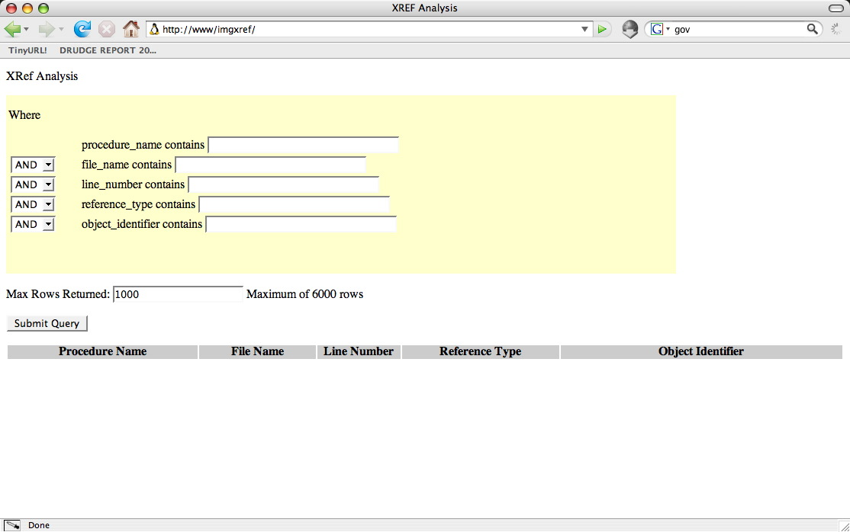
This screen allows you to search on the major components of an Xref file. If you leave the entry blank, it is ignored. If you wish to combine some entries do so by filling in the blank and choosing the conjunction to use.

Sometimes you can get a lot of entries returned – you can specify the maximum number of rows to return so you don't over-run your web browser.

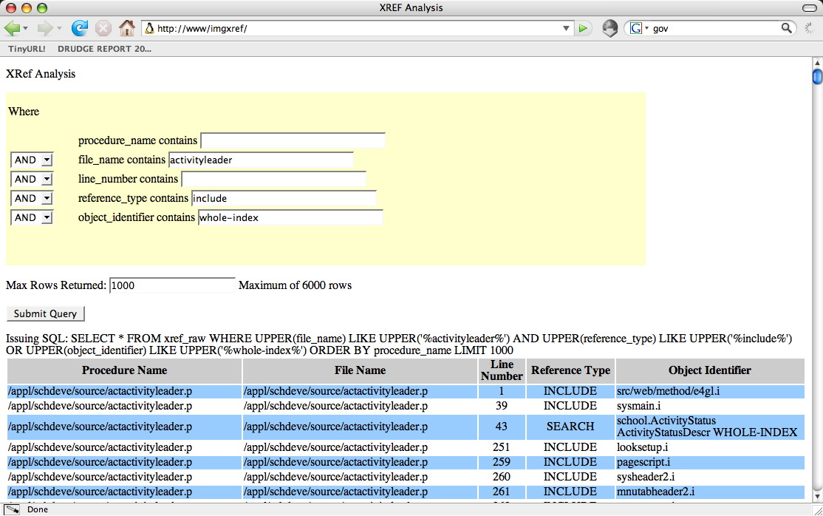
In this example, for the program named activityleader, tell us the INCLUDE files used as well as denote any table scans occurring (the whole-index keyword.)
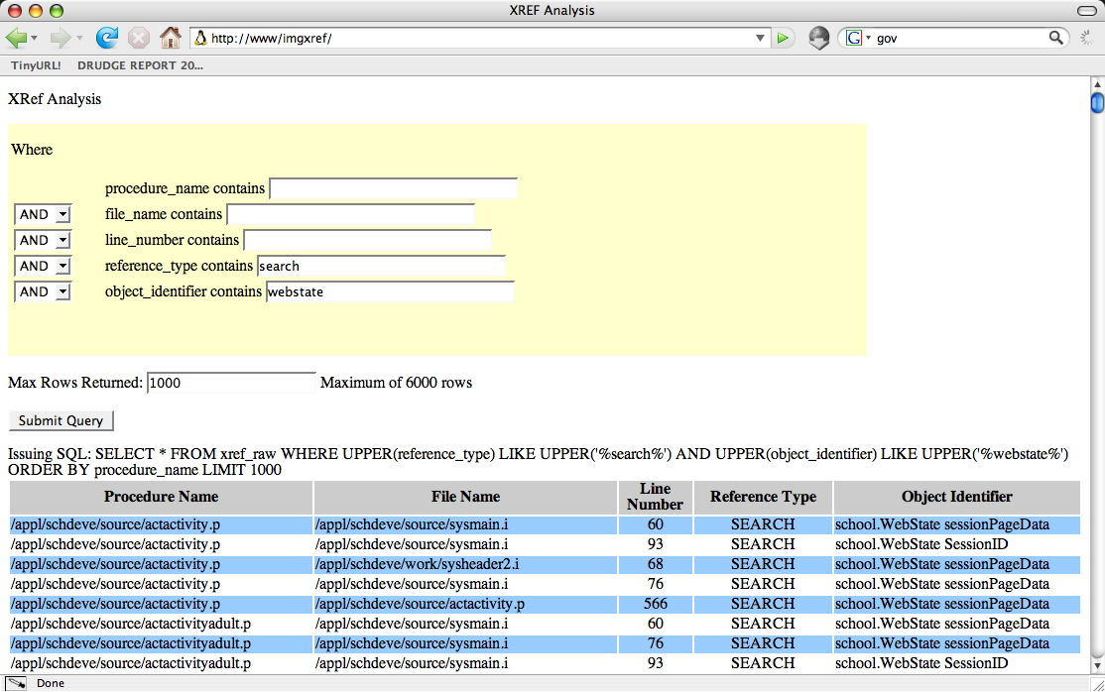
In the above example, we examine all the programs that do a search (FIND or FOR EACH or Dynamic Query) on the webstate table in the application.

Examine the COMPILE statement in the Language Reference Guide for additional terms to search on in the Reference Type and Object Identifier areas.

http://www.postgresql.org/ This is a pretty popular DB and one can see some of it's users at http://www.postgresql.org/about/users
http://www.php.net
http://www.rdesktop.org
Often you can find this in http://www.amduus.com/OpenSrc/SrcLib/XRefAnalysis
Using a GUI tool like http://www.pgadmin.org/screenshots/ or a web based tool like http://phppgadmin.sourceforge.net/index.php can make this much easier if you are unfamiliar with a command line tool.
http://www.amduus.com/OpenSrc/SrcLib/Zammi/
If you need more than 6000 rows to be returned, update the line 189 (or there abouts) in index.php that reads “if ($Limit > 5000) $Limit = 6000;” to the number you wish to max out at.

